

**WIDE-BELT GRINDER SPB PRODUCTION LINE**

**SPB 400 MAXX 4**

**SPB 800 MAXX 4**

**SPB 1100 MAXX 4**

**SPB 1350 MAXX 4**

ACCOMPANYING TECHNICAL DOCUMENTATION OPERATION AND MAINTENANCE GUIDE

Manufacturer: **HOUFEK a.s.**

May 5, 797 582 82 Golčův Jeníkov, Czech Republic

Page no. 1 / number of pages 48 + annexes Issue date: 2009

Update date: 11.5.2022

Documentation no.: 1

#### READ THIS GUIDE CAREFULLY PRIOR TO MACHINE COMMISSIONING!

content

1 INTRODUCTION 4

2 HYGIENE AND WORK SAFETY RULES; RESIDUAL RISKS; ENVIRONMENT, RESIDUAL RISK AND PREVENTION 5

2.1 QUALIFIED PERSONNEL 5

2.2 RULES OF SAFE WORK 6

2.2.1 GENERAL SAFETY RULES 6

2.2.2 WORKPLACE SAFETY RULES 7

2.2.3 SAFETY RULES FOR MACHINE OPERATION 7

2.2.4 SAFETY RULES FOR MACHINE MAINTENANCE 9

3 PURPOSE AND METHOD OF USE 11

3.1 MACHINE USE DEFINITION 11

3.1.1 WORK ACTIVITIES 11

3.1.2 MATERIALS WORKPIECE 12

3.2 WORK ENVIRONMENT 12

4 TECHNICAL DATA AND MACHINE DESCRIPTION 14

4.1 TECHNICAL DATA 14

4.2 MACHINE TECHNICAL DESCRIPTION – MAIN CONSTRUCTION GROUPS 16

4.3 MACHINE ADJUSTMENT AND SETTING FEATURES 25

4.4 MACHINE DESIGNATION – PRODUCTION PLATE 26

4.4.1 WARNING SIGNS 26

5 TRANSPORT, HANDLING & STORAGE 28

5.1 MACHINE TRANSPORT 28

5.2 MACHINE STORAGE 28

6 PLACEMENT, CONNECTING, AND PUTTING THE MACHINE IN TO OPERATION 29

6.1 MACHINE PLACEMENT 29

6.2 CONNECTION TO ELECTRIC NETWORK 30

6.3 PRESSURED AIR CONNECTION 31

6.4 CONNECTING DEVICE EXHAUSTING 31

6.5 FIRST START MACHINE 32

7 INSTRUCTIONS FOR USE, WORK PROCEDURES 32

7.1 GENERAL RULES FOR WORKING ON THE MACHINE 32

7.2 CONTROL – TURNING THE MACHINE ON AND OFF 32

7.3 ADJUSTMENT OF GRINDING UNITS 32

7.4 RINDING WITH ELASTIC ABRASIVE 33

8 GRINDING BELTS - REQUIREMENTS – STORAGE 33

8.1 GRINDING BELT STORAGE 33

8.2 GRINDING PAPER EXCHANGE 33

8.3 GRINDING PAPER PURCHASE 33

9 MACHINE MAINTENANCE AND SETTING 34

9.1 GRINDING BELT EXCHANGE 34

9.2 TENSION DRIVE CHAIN LIFTING TABLE 35

9.3 STRETCHING OF THE DRIVING BELTS OF GRINDING AGGREGATE 35

9.4 BRAKE SETTING 36

9.5 FEEDING BELT CENTRING AND TENSION CHECKING 37

9.6 INSPECTION AND ADJUSTMENT FUNCTION OSCILLATION 38

9.6.1 SETTING AND CHECKING PNEUMATIC CIRCUIT OSCILLATIONS 39

9.6.2 SET THE CENTER POSITION 40

9.6.3 OSCILLATION ADJUSTMENT 40

9.7 SETTING THE LIFT AND PRESSURE FORCE OF PRESSURE ROLLERS 40

9.8 REPLACEMENT ROTARY TOOLS - BRUSH WORK UNIT TYPE B 41

9.9 SETTING AND ADJUSTMENT OF THE MEASURING SYSTEM 42

10 MACHINE MAINTENANCE 43

10.1 MACHINE CLEANING AND LUBRICATION 43

10.2 MAINTENANCE OF FEATURES OF ELECTRICAL FITTINGS 44

10.3 MAINTENANCE OF FEATURES OF PNEUMATIC SYSTEM 44

10.4 MAINTENANCE PLAN FOR WILD BELT SANDER 44

11. TROUBLESHOOTING INSTRUCTIONS 46

12 MACHINE DISASSEMBLY AND LIQUIDATION 47

13 MACHINE LIFE 47

14 ACCESSORIES DELIVERED WITH THE MACHINE 47

15 SPARE PARTS AND THEIR ORDERING 48

15.1 IDENTIFICATION OF PARTS 48

15.2 ORDERING PARTS 48

16 SERVICE AND REPAIR SERVICES 48

16.1 CZECH REPUBLIC 48

16.2 OTHER COUNTRIES 48

17 MANUFACTURER'S CONTACT ADDRESS 48

# 1 INTRODUCTION

Dear customers,

Thank you for purchasing a wide-belt grinder, production line maxx 45, produced by our company. Its simple and safe operation, multipurpose use, and small size, together with suitable price, represent this machine’s chief advantages.

The **maxx 4** wide-belt grinder is made in compliance with valid technical standards and standards valid in the eu at the time this accompanying technical documentation is issued; a certificate of conformity has been issued.

Overview of technical regulations and standards, based on which the conformity of maxx 45 wide-belt grinder was assessed, is listed in ‘certificate of conformity’ for an production line wide-belt grinder; see this guide's annex.

Important instructions in this guide are marked with a warning sign . Moreover, they are in capital bold letters; you need to pay them special 

Attention.

We hope you will be happy with our product. In case of technical questions or a defect to the machine, contact manufacturer’s nonstop service or manufacturing plant’s sales dept., or an adequate national dealer authorised to sell our machines.

Aleš HOUFEK Houfek a.s. Board Chair

**WARNING:** BOTH THE TEXT AND PICTURES IN THIS GUIDE, INCLUDING ANNEXES, ARE PART OF INTELLECTUAL PROPERTY OF HOUFEK A.S. – Golčův jeníkov, AND REMAIN ITS PROPERTY. WITHOUT THIS COMPANY’S CONSENT, ANY PARTS OF THIS GUIDE MUST NOT COPIED, NOR ARE ANY THIRD PARTIES TO BE ALLOWED TO STUDY THIS GUIDE OR ITS PARTS.

# 2 HYGIENE AND WORK SAFETY RULES; RESIDUAL RISKS; ENVIRONMENT, RESIDUAL RISK AND PREVENTION

 WARNING!

BEFORE STARTING THE MACHINE, STUDY THIS GUIDE CAREFULLY. DETAILED KNOWLEDGE OF THIS GUIDE AND OBSERVATION OF ITS RULES WILL HELP YOU PUT THE MACHINE INTO OPERATION EASILY, ENSURING ITS OPTIMAL AND SAFE USE.

THE MANUFACTURER BEARS NO RESPONSIBILITY FOR INJURIES OR DAMAGE CAUSED BY IMPROPER USE, MAINTENANCE, AND PLACEMENT OF THE MACHINE.

QUALIFIED PERSONNEL IMPLEMENTING ASSEMBLY, PUTTING INTO OPERATION, MAINTENANCE, AND ATTENDANCE, MUST ALWAYS DEMONSTRABLY STUDY BOTH THIS GUIDE AND RULES OF SAFE MACHINE WORK BEFORE COMMENCING ANY SUCH ACTIVITY.

THE MANUFACTURER BEARS NO RESPONSIBILITY FOR INJURIES OR DAMAGE CAUSED BY AN UNQUALIFIED PERSON.

MACHINE NOISE

Acoustic volume levels: Equivalent levels of permanent acoustic pressure were discovered based on exactly defined measurement procedures. The following values may be declared:

|  |  |  |
| --- | --- | --- |
| Acoustic pressure - Lpa | dB | 83,4 |
| Acoustic volume - Lwa | dB | 94,9 |

Given values are the emission levels and do not have to represent safe working levels. Despite a correlation between emission levels and levels of exposure, these levels cannot be used for reliable definition of whether or not further measures are necessary. Factors influencing real levels of employee exposure include work area characteristics, other noise sources, etc., e.g. number of machines and neighbouring processes. Moreover, the highest acceptable level of exposure may differ in individual countries. This information should help the machine user to be able to assess the risks and risk levels better.’

## 2.1 QUALIFIED PERSONNEL



MECHANICS:

Expert workers appointed to implement maintenance and repairs (min. apprenticeship, e.g. in the fields of a fitter, machine mechanic, electrician) and trained (e.g. by either the manufacturer or service workers of authorised national dealers) to implement machine maintenance and repairs; and demonstrably introduced to this Guide; and with adequate electro-technical qualification based on valid national regulations and standards. The workers must not be under 18.

OPERATING STAFF:

Workers (men and women) not younger than 18 (if younger, then they must be at least 16 years old and work under supervision of a qualified worker over 18, e.g. within their training, field practice, etc. in compliance with adequate national regulations), who were demonstrably introduced to this Guide, tending, and basic maintenance.

## RULES OF SAFE WORK

### 2.2.1 GENERAL SAFETY RULES

 THIS MACHINE IS EQUIPPED WITH SAFETY DEVICES ENSURING BOTH SAFE WORK FOR THE OPERATING STAFF AND MACHINE PROTECTION AGAINST DAMAGE. sTILL, IT IS NOT POSSIBLE TO LIST ALL SAFETY ASPECTS OCCURRING WHILE WORKING WITH WORKPIECES OF VARIOUS SHAPES AND MATERIALS. IT IS THEREFORE ESSENTIAL FOR THE OPERATING STAFF TO STUDY THIS GUIDE CAREFULLY, AND UNDERSTAND ALL ITS PARTS; WHILE FOLLOWING ALL RULES LISTED HEREIN WHEN WORKING WITH SPB LINE MACHINES.

 FOLLOW ALL RULES AND INSTRUCTIONS ON THE PLATES ON THIS MACHINE. DO NOT REMOVE OR DAMAGE THESE PLATES. IF DAMAGED, THE PLATES MUST BE IMMEDIATELY REPLACED WITH NEW

ONES. NEW PLATES CAN BE ORDERED FROM THE MACHINE MANUFACTURER.

CHAPTER 4.3 MACHINE DESIGNATION – PRODUCTION PLATE GIVES AN OVERVIEW OF ALL PLATES WITH GRAPHIC SYMBOLS THAT MAY BE USED ON THIS MACHINE TYPE. STUDY THE MEANING OF THOSE GRAPHIC SYMBOLS.

BEFORE YOU START WORKING WITH THIS MACHINE, STUDY THE PLACEMENT AND FUNCTIONS OF INDIVIDUAL CONTROL FEATURES ON THE MACHINE’S CONTROL PANEL. MEMORISE THEIR POSITION, CHIEFLY THAT OF THE EMERGENCY BUTTONS, IN CASE YOU NEED TO USE THEM IN A HURRY.

ANY ACTIVITIES ON THE WIDE-BELT GRINDER LINE MAXX 4MAY ONLY BE PERFORMED BY

QUALIFIED STAFF, IN COMPLIANCE WITH RESOLUTION PART 2.1 QUALIFIED STAFF AND PART

5 PURPOSE AND METHOD OF USE; AS WELL AS RULES STATED HEREIN – STUDY THE GUIDE.

 CONNECT THE WIDE-BELT GRINDER LINE **MAXX 4** ONLY TO ELECTRICAL SYSTEMS THAT

MEET ADEQUATE NATIONAL REGULATIONS; THE SYSTEM MUST BE REVISED REGULARLY,

IN COMPLIANCE WITH ADEQUATE NATIONAL REGULATIONS. THE CONNECTION NETWORK

MUST BE OF IDENTICAL CONNECTION VOLTAGE; IT MUST BE DIMENSIONED FOR

RESPECTIVE INPUT BASED ON DATA ON THE MACHINE PLATE. THE MACHINE MAY ONLY

BE CONNECTED TO ELECTRIC NETWORK BY PERSONNEL AUTHORISED INCOMPLIANCE

WITH GIVEN NATIONAL REGULATIONS.

 HANDLING AND TRANSPORT OF WIDE-BELT GRINDERS LINE MAXX 4MUST FOLLOW INSTRUCTIONS GIVEN HEREIN, SECTION 5. TRANSPORT, HANDLING & STORAGE.

 WHEN LIQUIDATING THE MACHINE, FOLLOW RELEVANT NATIONAL REGULATIONS OR HAVE THE LIQUIDATION IMPLEMENTED BY A SPECIALISED FIRM. THE MACHINE IS MADE OF COMPONENTS AND MATERIALS HARMLESS TO PEOPLE AND ENVIRONMENT.

 IF THE CUSTOMER REQUIRES TO TURN THE GRINDING DIRECTION, TO THE OPOSITE GRINDING, IT IS NECESSARY TO INSTALL FLAPS TO PREVENT REVERSE THROW ON THE MACHINE INLET!

### 2.2.2 WORKPLACE SAFETY RULES

 INSTALL THE WIDE-BELT GRINDER ONTO AN EVEN SURFACE IN COMPLIANCE WITH RECOMMENDATIONS GIVEN IN THIS GUIDE. VERIFY FLOOR CAPACITY WITH REGARD TO MACHINE

WEIGHT.

CHECK THAT NO OBJECTS ARE PLACED ON THE WORKTABLE, AND THAT SIDE MACHINE DOOR AND  BOTTOM MACHINE COVERS ARE FASTENED TIGHTLY. CHECK THAT THE FEED TABLE WITH THE

BELT IS FREELY PASSABLE, AND THAT NO WORKPIECES, OR THEIR PARTS, ARE STUCK INSIDE THE MACHINE FROM PREVIOUS GRINDING.

PROVIDE SUFFICIENT LIGHTING, WITHOUT SHADOWS OR STROBOSCOPIC EFFECT, IN THE WORK  AREA. FOLLOW RESPECTIVE NATIONAL REGULATIONS. USUALLY, THE INTENSITY REQUIRED IS

500 LX.

THE WORK AREA AROUND THE MACHINE MUST BE FREE, CLEAN, AND DRY, SO THAT ALL CONTROL  FEATURES OF THE MACHINE ARE ALWAYS ACCESSIBLE IMMEDIATELY, WHILE ENSURING SAFE AND

FREE BOTH MOVEMENT AND HANDLING OF THE WORKPIECES FOR THE OPERATING STAFF. ITS SIZE IN FRONT OF AND BEHIND THE MACHINE NEEDS TO BE ADJUSTED WITH REGARD TO THE SIZE OF WORKPIECES. WHEN PLACING THE MACHINE, FOLLOW RULES STATED IN PART **6.1 MACHINE**

#### PLACEMENT.

 WHEN WORKING WITH THE WIDE-BELT GRINDER LINE **MAXX 4**PROTECTIVE ANTI-NOISE AIDS MUST BE USED. IN COMPLIANCE WITH RESPECTIVE NATIONAL REGULATIONS ON NOISE EMISSION

LEVELS, NOISE LEVEL AT THE WORKPLACE MUST BE MEASURED, BECAUSE THE TOTAL NOISE LEVEL INCLUDES ALL SOURCES OF NOISE AND ACOUSTIC CHARACTERISTICS OF GIVEN PREMISES. BASED ON VALUES MEASURED, FURTHER PRECAUTIONS FOR NOISE EMISSION LEVELS NEED TO BE DEFINED, E.G., MUTUAL BLOCKING OF INDIVIDUAL MAIN SOURCES OF NOISE.

### SAFETY RULES FOR MACHINE OPERATION

 BEFORE WORK COMMENCEMENT, ALWAYS PERFORM A REGULAR MACHINE CHECK. FOCUS ON CHECKING THAT THE WORKING ROLLERS ARE NOT DAMAGED AND THE GRINDING BELT IS NOT

EITHER DAMAGED OR BLUNT. THE GRINDING BELT MUST BE STRETCHED AND CENTRED BETWEEN THE END SWITCH ARMS (THEY HAVE A CERAMIC ROLLER). THE ROLLERS MUST BE CLEAN AND WITHOUT DAMAGE. DIRECTION OF THEIR MOVEMENT WHILE GRINDING MUST BE DESIGNATED ON THE BELTS. THE BELTS MUST BE MOUNTED ONTO THE MACHINE IN COMPLIANCE WITH MACHINE MOVEMENT – MARKED BY A RED ARROW (ON THE FRONT PANEL OF THE GRINDING UNIT).

ALSO CHECK THE PRESSURE ROLLERS AND PRESSURE BARS; AND RATCHET FUNCTION ON THE FIRST PRESSURE ROLLER THAT PREVENTS BACK EJECTION OF A WORKPIECE. USE HIGH QUALITY GRINDING BELTS WITH PERFECT JOINT, IN COMPLIANCE WITH RULES STATED IN PART 4.1 MACHINE TECHNICAL DATA.

CHECK INPUT VALUE OF PRESSURED AIR. IT IS FORBIDDEN TO TOUCH ANY OF ITS MOVING PARTS WHEN THE MACHINE IS RUNNING. DIRECTION OF THEIR MOVEMENT WHILE GRINDING MUST BE DESIGNATED ON THE BELTS. THE BELTS MUST BE MOUNTED ONTO THE MACHINE IN COMPLIANCE WITH MACHINE MOVEMENT – MARKED BY A RED ARROW (ON THE FRONT PANEL OF THE GRINDING UNIT).

 BEFORE COMMENCING WORK, CHECK THE FUNCTION OF EMERGENCY MACHINE HALT BY PRESSING THE EMERGENCY STOP BUTTON ON THE FRONT CONTROL PANEL, OR BY SWITCHING

THE MAIN SWITCH OFF, OR DEFLECTING THE STOP BAR. THE MACHINE MUST STOP WITHIN 10 SECONDS. **THE MACHINE MUST NOT BE USED IF THE EMERGENCY BRAKE DOES NOT STOP IT WITHIN 10 SECONDS, OR IF THE EMERGENCY BRAKE DOES NOT WORK.**



THE WIDE-BELT GRINDER LINE MAXX 4MUST NOT BE USED WITHOUT PERFECTLY FASTENED COVERS AND CLOSED SIDE DOORS. UPPER COVER OPENING IS PREVENTED BY A SAFETY LOCKING SWITCH. THE RIGHT HAND SIDE DOOR BY THE ELECTRICAL CONTROL PANEL IS LOCKED BY A SAFETY SWITCH. NEVER REMOVE THE COVERS, OR OPEN THE SIDE DOOR OR UPPER COVER, WHEN THE MACHINE IS RUNNING.

USE OF MACHINES WITH FUNCTIONLESS INTERLOCK MECHANISM OF INPUT THRUST ROLLERS BY

 WHEN WORKING ON THE MACHINE, WEAR WORK CLOTHES WITH FASTENED CUFFLINKS;

REMOVE ANY BRACELETS, PENDANTS, RINGS, AND WATCHES. REMOVE OR FASTEN LOOSE

SECTIONS OF CLOTHING. A LEATHER APRON MUST BE WORN ON ALL OPERATION STATIONS. WHILE WORKING, USE ALL PRESCRIBED WORK AIDS IN COMPLIANCE WITH RESPECTIVE NATIONAL REGULATIONS, SUCH AS WORK SHOES AND PROTECTIVE GOGGLES.

 OPERATOR MUST NOT STAND IN THE AXIS OF WORKPIECE LOADING AND UNLOADING SINCE IN CERTAIN CASES (WRONG LOADING, LOADING OF MULTIPLE PIECES, PART MALFROMATION,

PARALLE GRINDING ETC.) THE WORKPIECE MIGHT EJECT.

 PERSONS UNDER THE INFLUENCE OF ALCOHOL OR DRUGS ARE NOT ALLOWED TO OPERATE THE MACHINE.

 DURING THE MACHINE OPERATION IT IS PROHIBITED TO TOUCH ANY OF ITS MOVING PARTS.

 NEVER PLACE YOUR HANDS ON EITHER FRONT OR BACK SIDE OF THE TABLE; FEED BELT; INPUT/OUTPUT MACHINE AREA; OR WITHIN VICINITY OF WORKING ROLLERS AND PRESSURE ROLLERS WHILE THE MACHINE IS IN OPERATION. DON NOT HANDLE ANY OBJECTS WITHIN THE INPUT

AND OUTPUT MACHINE AREAS. IT IS FORBIDDEN TO TOUCH ANY OF ITS MOVING PARTS WHEN THE MACHINE IS RUNNING. NEVER PLACE ANY OBJECTS ONTO THE MACHINE’S WORKTABLE.

 IN THE EVENT THAT DURING THE MACHINING TO STOP OR WEDGE WORKPIECE IN A MACHINE PERFORM THE EMERGENCY MACHINE STOP. AFTER STOPPING THE MACHINE, MOVE THE UPPER

FRAME MOVING UNITS WITH SANDING UP AND RELEASE THE WORKPIECE ACCORDING TO THE PRINCIPLES SET OUT IN SECTION **4.2. EMERGENCY DESK LEAVE.**

#### IT IS FORBIDDEN TO INSERT MORE WORKPIECES INTO THE MACHINE IF PREVIOUS WORKPIECES ARE STUCK IN IT AND WORKPIECES CANNOT FREELY PASS THROUGH THE MACHINE.

NEVER PLACE ANY OBJECTS ONTO THE MACHINE’S WORKTABLE AND THE FEED BELT.

 USE ONLY THOSE MATERIALS FOR MACHINING THE MACHINE IS DESIGNED FOR. NEVER USE MATEIRAL MACHINING OF WHICH CREATES EXPLOSIVE ENVIRONMENT (E.G. ALUMINIUM).

 IT IS NOT ALLOWED TO PERFORM MACHINING OF VERY LARGE WORKPIECES OF HIGH WEIGHT PERFECT GUIDANCE OF WHICH ON THE WORKBENCH BY MEANS OF THRUST ROLLERS IS NOT

GUARANTEED.

IT IS FURTHER PROHIBITED TO PERFORM MACHINING OF PARTS SHORTER THAN THE MINIMUM ALLOWED LENGTH STATED IN PART 4.1 TECHNICAL DATA OF THE MACHINE; DUE TO IMPERFECT GUIDANCE ON WORKBENCH, WORKPIECE MIGHT GET WEDGED INSIDE THE MACHINE.

WHEN MACHINING LONG WORKPIECES, ENTRY AND EXIT OF WORKPIECES FROM THE MACHINE MUST BE PROVIDED ON THE WORKBENCH PLANE. FOR THE ABOVE REASON, ADJUSTABLE STEADIES WITH ROLLERS OR HEIGHT ADJUSTABLE ROLLER DESKS MUST BE USED ON THE ENTRY AND EXIT, OR THE POSITION OF THE WORKPIECE MUST BE STABILISED MANUALLY.

USE ONLY HIGH QUALITY UNDAMAGED OR NON-DEFORMED ABRASIVE BELTS FOR GRINDING; THE  QUALITY OF THEIR JOINT MUST BE HIGH. THE BELTS MUST HAVE INDICATED DIRECTION OF MOVEMENT IN GRINDING, AND THEIR FITTING TO THE MACHINE MUST BE PERFORMED

ACCORDINGLY WITH THE MACHINE MOVEMENT, AS INDICATED BY THE RED ARROW. (ON THE FRONT PLATE OF THE GRINDING UNIT).

 DO NOT OVERLOAD THE MACHINE DURING OPERATION; CHECK THE LOAD BY AMMETERS MEASURING THE working current OF GRINDING UNITS’ MOTORS. MAXIMUM ALLOWED CURRENT

VALUE IS DESIGNATED ON THE AMMETER SCALE WITH A RED MARK.

 ALWAYS HAVE THE MAIN SWITCH TURNED OFF AND LOCKED WHEN PERFORMING CLEANING, CHECKS, MAINTENANCE, AND MACHINE REPAIRS TO AVOID MACHINE STARTING BY ANOTHER

PERSON.

CLEAN THE MACHINE REGULARLY, AT LEAST ONCE A WORK SHIFT. ADJUST MACHINE CLEANING TO PERIOD OF OPERATIng TIME. CLEANING WITH PRESSURED AIR IS FORBIDDEN. CLEAN THE MACHINE STRICTLY BY SUCKING THE DIRT OFF.

 AFTER YOU FINISH WORK, SECURE THE MACHINE AGAINST STARTING BY AN UNAUTHORISED PERSON: TURN OFF THE MAIN SWITCH AND LOCK IT IN THE OFF POSITION USING A PADLOCK; AND

CLOSE OFF THE PRESSURED AIR INLET BY A MANUAL VALVE ON THE INPUT UNIT OF PRESSURED AIR ADJUSTMENT UNIT (CLOSED - VALVE CONTROL IS IN TRANSVERSE POSITION TO THE SUPPLY PIPELINE).

### SAFETY RULES FOR MACHINE MAINTENANCE

 BEFORE STARTING ANY MAINTENANCE WORK ON THE MACHINE, TURN THE MAIN SWITCH OFF AND LOCK IT. ITS ACCIDENTAL STARTING BY ANOTHER PERSON IS THUS PREVENTED. THE MAIN

SWITCH DOES NOT DISCONNECT THE MACHINE FROM THE PRESSURED AIR SUPPLY.

BEFORE STARTING MAINTENANCE AND CLEANING OF THE MACHINE, IT IS THEREFORE ESSENTIAL TO SWITCH THE BALL VALVE ON THE PRESSURED AIR INPUT UNIT INTO THE OFF POSITION (RED VALVE CONTROL IS TRANSVERSE TO THE SUPPLY PIPELINE AXIS).

 ELECTRICAL INSTALLATION MAINTENANCE MAY ONLY BE PERFORMED BY ADEQUATELY QUALIFIED PERSONNEL IN COMPLIANCE WITH RESPECTIVE NATIONAL REGULATIONS.

 NEVER USE PRESSURED AIR TO CLEAN THE ELECTRICAL CONTROL PANEL. ALWAYS SUCK THE DIRT OFF. THIS IS GENERALLY VALID FOR THE ENTIRE MACHINE.

IF THE OPERATING STAFF DISCOVER DAMAGE TO THE SEALING ON THE ELECTRICAL CONTROL  PANEL LID OR A LEAK BETWEEN A BUSHING AND A CABLE, THE DEFECT MUST BE REMOVED

IMMEDIATELY. FILINGS AND DUST MAY CAUSE A short circuit ON AN ELECTRICAL DEVICE.

 ALWAYS CHECK AND CLEAN THE MACHINE BASED ON THE AMOUNT OF ITS USE; THE MINIMUM IS ONCE IN A WORK SHIFT. CHECK THE FUNCTION OF PRESSURE ROLLERS, ESPECIALLY THE

RATCHET ON THE FIRST PRESSURE ROLLER. THIS MECHANISM, TOGETHER WITH THE FIRST PRESSURE ROLLER, PREVENTS WORKPIECE BACKWARDS EJECTION FROM THE MACHINE. POSSIBLE REPAIRS MUST BE SUBMITTED TO QUALIFIED MECHANICS. WHEN EXCHANGING HE GRINDING BELTS, AS WELL AS WHEN CHECKING AND CLEANING THE MACHINE, DISCONNECT IT FROM THE ELECTRICAL ENERGY NETWORK BY SWITCHING OFF THE MAIN SWITCH (BY TURNING THE MAIN SWITCH CONTROL TO ‘O’).

 BOTH THE SUPPLY CABLE AND ELECTRICAL FITTINGS MUST BE CHECKED REGULARLY, IN COMPLIANCE WITH RESPECTIVE NATIONAL REGULATIONS. DAMAGED CABLES AND PLUGS, OR

OTHER ELECTRICAL FITTING COMPONENTS, IF APPLICABLE, MUST NOT BE USED. DAMAGED INSULATION OR DAMAGED COMPONENTS OF ELECTRICAL FITTINGS, IF APPLICABLE, PRESENT A LIFE THREAT. FREE ELECTRICAL PARTS (CABLES) MUST BE PROTECTED AGAINST MECHANICAL DAMAGE, AND THEY MUST NOT CREATE AN OBSTACLE IN THE WORKING AREA.

WHEN EXCHANGING ANY COMPONENTS AND MACHINE PARTS, IT IS ESSENTIAL TO USE ORIGINAL

 SPARE PARTS BY THE MANUFACTURER, BASED ON A SPARE PARTS CATALOGUE DELIVERED BY THE MANUFACTURER OR HIS AUTHORISED DEALER.

WHEN LIQUIDATING the MACHINE, FOLLOW RESPECTIVE NATIONAL REGULATIONS; OR SUBMIT THE  LIQUIDATION TO A SPECIALISED FIRM. THE MACHINE IS MADE OF COMPONENTS AND MATERIALS

HARMLESS OT BOTH PEOPLE AND ENVIRONMENT.

RISKS ASSOCIATED WITH THE OPERATION OF WIDE-BELT GRINDING MACHINE LINE MAXX 4UNDER THE ASSUMED APPLICATION AND LOGICALLY ANTICIPATED INCORRECT APPLICATION WERE MINIMIZED BY MEANS OF AVAILABLE TECHNICAL MEASURES.

DESPITE THE APPLIED CONSTRUCTIONAL AND TECHNICAL MEASURES, CERTAIN RESIDUAL RISKS INVOLVED DURING MACHINE OPERATION REMAIN, AS INDICATED IN THE RISK ANALYSIS, WHICH ARE GIVEN BY THE TECHNOLOGICAL PROCESS DURING VARIOUS PHASES OF THE SERVICE LIFE OF THE MACHINE.

THESE RISKS SPECIFICALLY RESULT FROM WORKER INATTENTION AND BY FAILING TO ADHERE TO SAFETY PRINCIPLES DURING OPERATION.

WE CAUTION AGAINST RESULTING RESIDUAL RISKS TO FURTHER REDUCE THE RISKS AND TO SECURE EFFECTIVE SAFETY PROTECTION. WE SPECIFY THE FOLLOWING TECHNICAL AND ORGANIZATIONAL MEASURES TO BE PERFORMED BY THE USER, WHICH ARE DESIGNATED FOR OVERCOMING THE RESPECTIVE RISKS AND DANGER

#### RISKS ON THE ELECTRICAL PART OF THE MACHINE

CONNECTING, MAINTENANCE, REPAIRS, AND REVISIONS OF ELECTRICAL EQUIPMENT MAY ONLY  BE PERFORMED BY QUALIFIED, PROFESSIONAL MECHANICS IN ACCORDANCE WITH APPROPRIATE

NATIONAL REGULATIONS AND STANDARDS.

 ANY DAMAGE TO THE ELECTRICAL EQUIPMENT MUST BE REPAIRED WITHOUT DELAY. DAMAGED EQUIPMENT MUST NOT BE USED.

 ANY MODIFICATION OF THE SAFETY CIRCUITS, AND/OR ANY UNAUTHORIZED ACTION THAT ALTERS THE RELIABILITY AND SAFETY OF THESE CIRCUITS IS STRICTLY FORBIDDEN.

 CIRCUITS CONNECTED UPSTREAM OF THE MAIN SWITCH ARE CONSTANTLY UNDER VOLTAGE. CIRCUITS ARE DESIGNATED BY WARNING LABELS AND CONFORM TO THE IP 20 CODE.

RISKS ON THE MECHANICAL PART OF THE MACHINE RISK OF PRESSING:

 RISK OF PRESSING MAY OCCUR WHEN THE GRINDING UNIT (FRAME) MOVES TO SMALL REDUCTIONS AND DUE TO INCORRECT HAND POSITION.

 RISK OF: - CUTTING (OFF)

* WINDING ON
* PULLING IN OR CATCHING

These risks may occur when moving around the grinding belt.

Any movement within this area, when the grinding aggregate is rotating, is forbidden. A safety circuit (end switch on the door) prevents access to these premises during operation. Adjusting the grinding belt oscillation represents an

exception; here, the operating staff are near the grinning aggregate in service menu. In such a case, a safety circuit prevents belt slipping and tearing; the operating staff are also protected by the aggregate beam. Moreover, the motor is only turned on and off briefly, and runs down by inertia, where the risk is improbable.

#### ACCESS TO DANGEROUS PLACES ON THE MACHINE:

 It is necessary to be familiar and observe all safety regulations concerning dangerous places on the

machine.

#### ACCESS OF OUTSIDE EMPLOYEES TO THE WORKPLACE:

 Access of outside employees to the workplace needs to be prevented by local operation regulations

processed by the user.

#### ACCESS TO MOVING MACHINE PARTS FROM VARIOUS SIDES:

 Areas designated as dangerous must be under constant supervision of an attending employee.

#### NOISE LEVELS

 - Machine noise levels exceed the maximum admissible values in compliance with valid standards.

- The use of protective equipment is therefore mandatory. 

**OTHER RISKS AND HAZARDS**

All employees must be formally trained and introduced to machine use.

 All workers must use personal protective aids prescribed, in compliance with Chapter 2.2 - WORK SAFETY.

 IT IS ESSENTIAL TO STUDY THE WORK SAFETY CHAPTER BEFORE STARTING THE MACHINE

Operating staff must report any defects on the machine and its equipment, chiefly those threatening operational safety, to either a workshop foreman or their superior; the defects must be removed. Defect type and their removal must be recorded in a defect log.

**WARNING!** THE MANUFACTURER REFUSES TO RECOGNISE DAMAGE COMPENSATION CLAIMS FOR DAMAGE INCURRED BY FAILING TO OBSERVE THE RULES DEFINED HEREIN.

# PURPOSE AND METHOD OF USE

## MACHINE USE DEFINITION

### 3.1.1 WORK ACTIVITIES

Wide-belt grinders line **MAXX 4**are machines of modular construction, which allows arranging machines based on customer’s requirements. To ensure required work tasks, the machines may be mounted with various work units and their combinations.

**R** - Sanding unit with working cylinder

**B** - unit adapted for mounting cylindrical grinding and polishing tools

**D** - unit is designed for assembling the disc tools (brushes)

THE MACHINE IS DESIGNED FOR TWO OPERATORS.

 THE MACHINE COMMONLY GRINDS IN PALLALEL. IN SUCH CASE, IT IS IMPOSSIBLE TO MECHANICALLY SECURE THE MACHINE TO PREVENT THE PRODUCT FROM FLYING FROM THE MACHINE. IF THE CUSTOMER

REQUIRES TO TURN THE GRINDING DIRECTION, TO THE OPOSITE GRINDING, IT IS NECESSARY TO INSTALL FLAPS TO PREVENT REVERSE THROW ON THE MACHINE INLET!

### MATERIALS WORKPIECE

The **MAXX 4** wild-belt sanders are designed for rough or fine grinding, or for polishing of metal plates, belt materials and jeckels of metal materials.

 WORKPIECE MIN. AND MAX. PARAMETERS MUST BE ADHERED TO IN COMPLIANCE WITH VALUES LISTED IN PART **4.1 MACHINE TECHNICAL DATA.**

EXTREMELY LARGE AND HEAVY WORKPIECES THAT CANNOT BE PERFECTLY GUIDED ON THE  WORKTABLE USING PRESSURE ROLLERS MUST NOT BE WORKED ON THE MACHINE.

IT IS FORBIDDEN TO WORK WITH PIECES SHORTER THAN THE MINIMUM ALLOWED LENGTH

DEFINED IN PART 4.1 MACHINE TECHNICAL DATA, DUE TO IMPERFECT GUIDING ON THE WORKTABLE AND POSSIBILITY OF WORKPIECE JAMMING INSIDE THE MACHINE.

WHEN WORKING LONG WORKPIECES, THEY MUST COME IN AND OUT OF THE MACHINE AT TABLE LEVEL. IT IS THEREFORE NECESSARY TO USE ADJUSTABLE SUPPORTS WITH ROLLERS, OR TABLES WITH ADJUSTABLE HEIGHT, OR POSITION THE WORKPIECE MANUALLY ON BOTH INPUT AND OUTPUT.

LOAD WORKPIECES IN MACHINE ONE BY ONE. IN CASE OF MULTIPLE WORKPIECES ARE MACHINED  AT ONCE, MINIMUM HEIGHT DIFFERENCE OF THESE WORKPIECES MUST BE ENSURED TO PROVIDE

PERFECT GUIDANCE AND FEEDING OF WORKPIECES AT THE ENTRY TO THE MACHINE AND EXIT

FROM THE MACHINE BY MEANS OF THRUST ROLLERS, AND THAT THE ROLLERS SECURE ALL LOADED WORKPIECES. IT IS FURTHER NECESSARY THAT ONLY ONE WORKPIECE IS MACHINED AT A TIME OF ALL THOSE THAT PASS THE MACHINE

IT IS FORBIDDEN TO ENTER MATERIAL THAT, DUE TO PREVIOUS GRINDING (HEAT), CHANGED  ITS ORIGINAL SHAPE (GOT BENT OR CROOKED) INTO THE MACHINE. YOU MUST WAIT FOR THE

MATERIAL TO COOL OFF AND RETURN TO ITS ORIGINAL SHAPE.

## 3.2 WORK ENVIRONMENT

WIDE-BELT GRINDERS LINE CINDY 3M(W) ARE DESIGNED FOR A WORKSHOP ENVIRONMENT OF  TEMPERATURES FROM +5 TO 40 °C, AND RELATIVE AIR HUMIDITY OF 30% TO 95% - NON-

CONDENSING ENVIRONMENT CLASSIFICATION – FIRE RISK OF FLAMMABLE DUST BE2N2.

* 1. **METHOD OF USE**

Wide-belt grinders line MAXX 4may only be used in compliance with rules stated herein. Rules given in the following parts of this Guide must be absolutely followed:

* 1. QUALIFIED PERSONNEL
  2. RULES OF SAFE WORK
     1. WORK ACTIVITIES
     2. WORKPIECE MATERIALS

3.2 WORK ENVIRONMENT

4.1 TECHNICAL DATA

7 INSTRUCTIONS FOR USE - WORK PROCEDURES

1. MACHINE MAINTENANCE AND SETTING

# 4 TECHNICAL DATA AND MACHINE DESCRIPTION

## 4.1 TECHNICAL DATA

|  |  |  |  |  |  |  |
| --- | --- | --- | --- | --- | --- | --- |
| Technical data | units |  | 400 | 800 | 1100 | 1350 |
| Work width | mm |  | 400 | 800 | 1100 | 1350 |
| Grinding belt width | mm |  | 430 | 830 | 1120 | 1370 |
| Workpiece height | mm | 0,5-160 | | | | |
| Grinding belt length | mm | 1900 | | | | |
| Grinding belt speed | m/sec | 18 | | | | |
| Operating roller diameter | mm | 120 | | | | |
| Engine power sanding belt | Kw |  | 7,5 | 11 | 11 | 11 |
| Speed of feeding belt | m/min | 2-10 | | | | |
| Input of feeding belt moto | Kw | 0,55-2,5 (according to the machine configuration) | | | | |
| Supply voltage | V/Hz | 3x400V/50Hz | | | | |
| Compressed air consumption without blowing/with blowing | l/min | 50/200-300 | | | | |
| Inlet working pressure without  blowing/with blowing | BAR | 5.5/8 | | | | |
| Diameter of exhaust opening | mm | 150 | | | | 180 |
| Exhaust device power output | m3/hod |  | 2.5-  4thous. | 4-  6thous | 4-  6thous. | 5-8thous. |
| exhaust air velocity | m/sec | 20 | | | | |

|  |  |  |
| --- | --- | --- |
| **Configuring the unit** | **R** | **B** |
| Minimum workpiece | 300 | 420 |

**Dimensions between rollers according to machine configuration:**

Agregat R

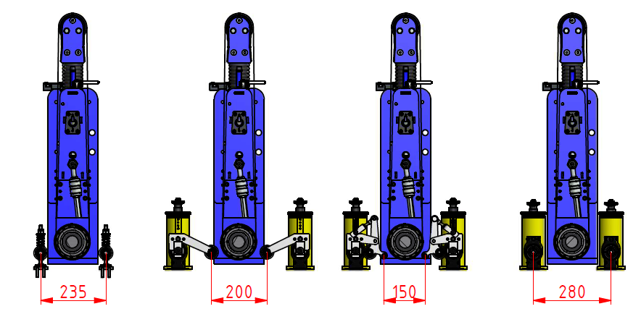

**Standard rollers Lever simple Lever double Standard Covered**

Agregat D

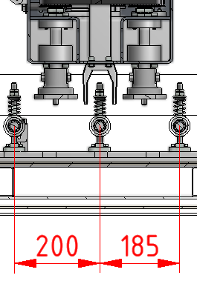

Some technical parameters are adapted if special machine equipment is used which is delivered upon customer's request.

## 4.2 MACHINE TECHNICAL DESCRIPTION – MAIN CONSTRUCTION GROUPS

The production line of MAXX 4grinders represents machines of modular construction, which allows arranging machines based on customer’s requirements. The machines have basic design groups, the technical description of which is given below. Each design group is delivered in its standard version. On customer’s request, these standard- delivered groups may be completed or adjusted by further accessories expanding or adjusting their work options (including higher power of driving motors). The following description of design groups focuses on the standard- delivered versions first; it then includes further adjustment and accessory possibilities of the design groups.

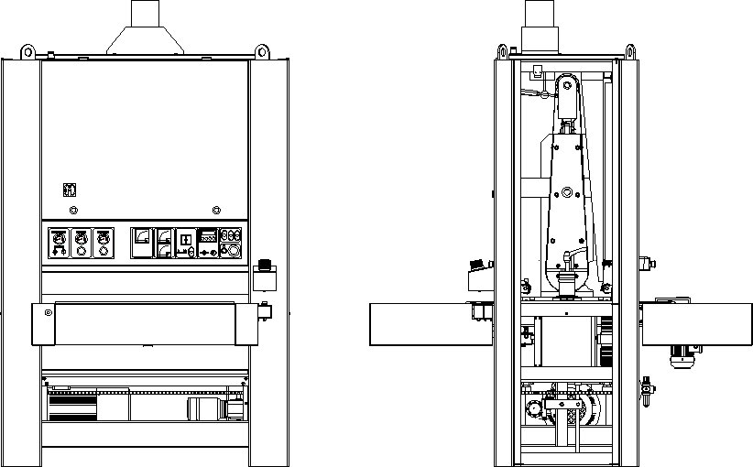

5

6

4

10

2

8

3

7

1

9

1. – machine frame 6 - stop bar
2. - desk with the feed belt 7 - sheeting, doors, covers
3. - work Unit R 8 - control panel
4. - drives working units 9 - wiring
5. - pressure rollers and rinsing modules 10 - lift drive transformable frame

#### MACHINE FRAME –1

The frame is welded from steel bent sections of wall thicknesses 5 and 6 mm. Profiles are arranged so that the structure safely captures the forces generated during machining without any deformations. In the lower part of the frame are suspended driving flange motors for work units. Suspension engines is done in vertical grooves plates to the frame, allowing tension V-belt drive.

Frame dimensions are modified according to the working width of the machine and the number of working units installed In the middle of the side parts of the frame are hinged on the two rails screw bearing table with a feed belt. On the left hand side part of the frame are suspended work unit type R for grinding In front of the upper part of the frame is made of electrical switchgear cabinet. On the front side of the frame, the opening panel with controls electrical and pneumatic installation.

#### Work Unit Type R 3

5.2.1 1 POWER OF WORKING UNITS

5.2.1 2 PRESSURE ROLLERS

5.2.1 4 XHAUST SYSTEM

5.2.16 PNEUMATIC SYSTEM

5.2.1 8 SETIING ANO ADJUSTING U ITS OF

5.2.1 9 SECURITY SYSTEM OF MACHINE

Work Unit Type R is the basic design group designed for grinding workpieces. Standard equipment of the unit is a hollow cylinder with a diameter of working with 160 mm solid shaft. The working cylinder is grooved on the surface covered with a rubber coating. Folding is done in the helix. Cylinders are supplied standard with a rubber coating hardness of 60 ° Sh different variants according to the standard machines. Saving cylinder shaft is made on the enclosed ball bearings that can not be refilled during operation grease. The shaft stroke is completed eccentric pins, which allow height adjustment of the position of the cylinder. For machines with only one grinding unit Type R comes standard drum sound, which can be height adjusted. Transfer from the engine is made by V-belts on the pulley, which is part of the war. Right front side of the grinding unit is removable for easy exchange of the working cylinder. At the lower beam unit is mounted pneumatic cylinder which extends tensioning rod with a shoulder on which is stored sanding belt tensioning roller. Rod is mounted on the piston rod pneumatic cylinders, tapered roller bearing, which ensures free rotation pole with arm and tensioning roller. This rotation is necessary for oscillation of the belt. Upper arm tensioning cylinder is placed on the tensioning rod to pivot. This deposit provides tilting arm with the jack cylinder required for perfect sanding belt guidance. Pneumatic cylinder control is done by manual control, located on the right front panel of the grinding unit. Cylinder lifting mechanism is located on the left side plate. According to standard versions of machines is controlled either manually lifting the adjusting nut, or a pneumatic cylinder supplemented adjusting nut with adjustable basic working position.

Grinding belt drive rollers oscillate sideways. Oscillation is controlled by the IF sensor mounted on the upper beam unit. The sensor monitors the left side of the sanding belt. When reflecting beam from the edge of the grinding belt sensor switches the pneumatic valve which controls the oscillation pneumatic cylinder with a rod that rotates arm tensioning cylinder. Repetitiverepositioning tensioning cylinders causing oscillation of the grinding belt. Limit sanding belt position limit switches are protected with ceramic roll. Sanding belt tension is controlled by a limit switch arm fitted with a small pulley that fits into the fork placed on the tension rod. In the event that any of the limit switches, position the belt or belt tension is not in the position of the control voltage is disconnected the machine and the machine is braked by the motor brake. The working unit is mounted in the machine frame on the left side of the machine with screws. On the left side is the location of the work unit to ensure a height-adjustable backrest and secured with a screw handle. With adjustable backrest can be adjusted by mutual parallel position of the grinding roller and the feed table.

#### Grinding rollers with two working positions

Both of the above grinding unit type R and C can be supplied in arrangement for two working positions working cylinders. This modification allows you to set two working positions with mechanical end stops. Change of these preset positions is done by pneumatic cylinders controlled by electrical valves. The switch that is used to set the roller into the desired position is located on the control panel. The switch has three positions: non-working - cylinder lifted, first working and the second working position.

#### SANDING ROLLERS AND SANDING PADS AS OPTIONAL EQUIPMENT

 SHIFTING AND ADJUSTMENT OF ROLLERS SANDER BOTTOM END DURING GRINDING (ROUTING), OR WHEN MATERIAL IS LOADED UNDER THESE UNITS, ARE NOT ALLOWED.

#### WORK UNIT TYPE B

5.2.1 1 POWER OF WORKING UNITS

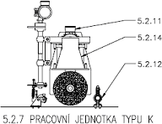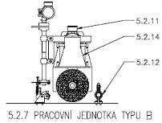

5.2.1 2 PRESSURE ROLLERS

5.2.1 4 XHAUST SYSTEM

5.2.16 PNEUMATIC SYSTEM

5.2.1 8 SETIING ANO ADJUSTING U ITS OF

5.2.1 9 SECURITY SYSTEM OF MACHINE

This work unit is designed for mounting cylindrical tools (brushes) to a diameter of 300 mm. Working tool is mounted on the drive shaft with circular nuts. The shaft is mounted on self-aligning ball bearings mounted on the side of the unit. Replacement of tools is necessary to remove the right side plate bearing units. The drive shaft of the motor is made using V-belts. Belt tensioning is performed traverse motor flange on the left side unit on which the engine is mounted. Serves to tension the tensioning screw.

By the diameter of the cylindrical tool used, or according to the degree of wear is necessary to set the optimum height of the tool and workpiece . Setting the height adjustment is done throughout the unit to zero height of the machine (height other working units). The adjustment is done using two motion screws interconnected steel chain . The tension of the chain tensioner is used. Lift drive unit is made with worm gear motor. Lower and upper limit position of the unit is secured with limit switches. The driver stroke is located on the control panel of the machine.

#### WORK UNIT TYPE D

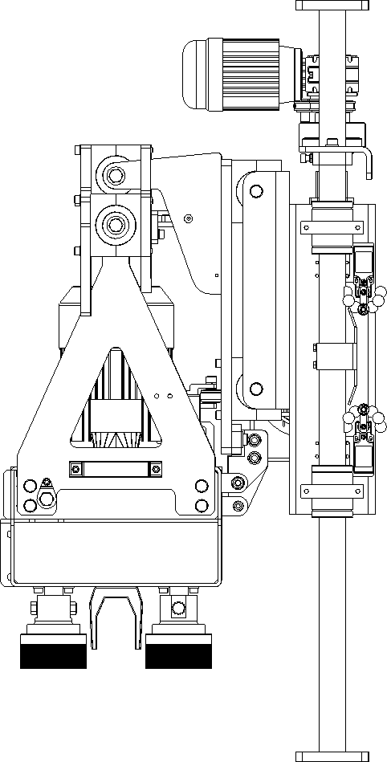This working unit is designed for assembling the disc tools (brushes) up to diameter 115 mm. The working tool (disc brush) is assembled on the shaft of the unit by means of fastening in the aluminium carrier – bayonet. The shafts of individual brushes are placed in the ball bearings placed in the aggregate housing. The shaft movement from the motor is designed by means of teeth chains. The chain stretching is performed by shifting the stretching band pulley in the aggregate front part. The stretching screw is used for stretching.

According to to the level of the tool wear it is necessary to set the optimum tool height and the workpiece height. The setting is performed by the height resetting of the full unit to the zero height. The resetting is performed using four moving screws interconnected with the sling chain. The stretches is used for stretching of the chain. The unit lift is made with electrical motor with the worm gear. The lower and upper position of the unit is secured with limit switches. The lift controller is located on the machine control panel. This grinding unit is completed with oscillation which is resolved by means of eccentric shaft propelled by motor with screw gear. Eccentric shaft is connected via a bearing with the arm which forms the oscillating movement of brush with the cabinet where it is located. The brush cabinet is suspended on two horizontal bars where it slides by means of linear ball line.

Better tool replacement is provided by aggregate moving from the machine. To enable the moving out, it is necessary to avoid the sensors. The aggregate is therefore equipped with mechanism, to prevent the moving out in incorrect - lower position. It is

necessary to press the lift button to move out the aggregate to upper position. It is necessary to switch the key to the service position on the main control panel to activate the button.

**WORK TABLE WITH A BAND FEED MOTION SCREW - 2**

Desk with feed belt used to move forward and keeping workpieces under work units. The basis of the table is polished steel plate, which is guided by feed belt with workpieces. In the middle of the table plate are bolted to side panels, which are mounted in front of the guide plate for the front idler roller. The rear side panels are fastened with self- aligning ball bearings covered drive roller and does not need to be lubricated during operation. For easier removal table (belt replacement - cylinder) is a right side profile table in the back of the split. Transmission with drive motor is fitted on the shaft and fitted with roller arm . The front idler roller is mounted on a fixed shaft on ball bearings. Bearings are double covered. Shaft ends are strings that are stored in the guiding plates. Shafts are screwed into the tensioning screws are used to feed belt tension. The front and rear of the table are auxiliary pressure rollers to facilitate the laying of large workpieces. At the front and rear of the table are the side covers bolted sheet steel. The table is mounted with 4 screws to the joists. The beams are hung with table motion nut bolts. This store allows you to set the desired positions of the table due to grinding units. Screw is four and are hung in high sidewall frame rails. Screw are stored on tapered roller bearings. Threads motion screws are covered with dust sleeves. Nut bolts are fitted with bronze threaded insert. Drive screws is done with chain tensioner and an electric motor with worm gear. The standard single- speed motor.

Standard equipment table consists rubber feed belt driven worm gear. The need for setting the optimal speed feed belt grinding is supplied adjustment of the drive motor belt feed by frequency inverter

This solution ensures smooth change of the feeding belt speed within the range from 2 to 10 m/min. Change in speed is performed in a standard manner by means of potentiometer. The value of the selected feeding speed is deducted on numerical scale with potentiometer located on the control panel of the machine or - for machine with NC control - the information of currently set speed is shown on the display in m/min.

#### Equipment pickup table available on request – optional eqipment Automatic centering of feeding belt

Way to control the position of the belt in this case is resolved electro. Edge of the belt is controlled by a mechanical sensor that controls the electro-pneumatic valve. This valve controls the distribution of compressed air into the cylinder, which pushes the front right side of the tensioning roller. Move the tensioning cylinders on the right side is controlled by the position of the feed belt.

#### Extension work table.

In the event that the grinding large parts, it is possible to add to a standard table extension modules, which are equipped with two rollers. Module length is 300 mm. Extension modules can be mounted on the input and output side of the feed table.

#### Vacuum table

If the grinding machine of small size parts, or parts for a very small thickness and is neither provided the perfect lead on the feeder belt, vacuum table can be supplied with holes in the top plate and perforated feeder bands. The inner part of the table is sucked vacuum pump flexible hose attached to the table. The vacuum pump is supplied as optional equipment, and it must be ordered separately. Resulting vacuum through the holes in the table top and the pump sucks belt parts for the feed belt and thus increases the strength of the parts are maintained on the feed belt.

#### Two speed lifting worktable

To increase operator comfort and to achieve the shortened time when rebuilding table lift table can be equipped with two-speed motor. The system operates so that when the table adjustment is achieved first standard speed and after about 5 seconds the speed is automatically doubled

#### WORK UNIT DRIVE – 4

As standard, machines line MAXX 4are delivered with electromotors of powers given in part 4.1 TECHNICAL DATA. Aside from these power parameters, the machines may be equipped with different power and supply voltage based on

order. Driving electromotors are flanged and are located in the lower part of the machine. attachment allows vertical displacement of the motors for tensioning V-belts with tensioning screws. Motors are equipped with electro-pneumatic disc brakes connected in the serial safety circuit of the machine.

Additional equipment – optional

For the need of setting optimum cutting speed sanding belt, or the speed of the working units of type B can be equipped with machine two speed motors, or motors whose speed is controlled by frequency converters. Speed control can be supplied with either a control potentiometer on the control panel of the machine as indicating the currently set speed (rpm), the management or control systems using the touch panel.

#### PRESSURE ROLLERS – WORKPIECE GUIDING - 5

As standard, the MAXX 4line machines have pressure rollers with rubber coated surfaces; they are 50 mm in diameter and rubber coating hardness of 45°Sh. Input and output rollers of the machine are placed on the pivoted arms. Inner rollers, the aggregates are moved vertically along the guide pin. For both types of rollers can be set lower position and contact forces by spring tension.

Input roller is equipped with ratchet pawl which prevents any backward throwing the workpiece.

#### SHEETING – DOORS – COVERS - 7

Machine frame construction has steel sheet panels, which are filled with noise and anti-matter

.Cover panels may be dismounted. The lower part of the machine is covered by three panels in the middle and two side panels on machine. The top rear of the machine and the upper part of the frame is covered always one panel. On the top panel are mounted exhaust pipes . Side door allows easy access to the grinding aggregate for adjustment, maintenance, and cleaning. Doors are also filled with insulating material. The electrical control panel box is placed in the upper front part of the machine. The control panel can be easily accessed after lifting the front door. Doors are filled with insulating material

#### EXHAUST SYSTEM MACHINE

Each work unit machine is equipped with a separate suction channel that is terminated at the level of the workpiece suction slit opening. Outlets extraction channels through the upper cover panel to which are bolted suction transitions. The circular pin transitions connect suction hose.

Exhaust system ensures perfect suction machines only when suction equipment meets the minimum specifications listed in section **4.1 TECHNICAL DATA.**

#### ELECTRICAL FITTINGS - 9

Electrical installation is performed in accordance with respective standards; it meets the CE (UL, cUL, CSA) standard. The machine is connected to the electric network by a cable (must have a guard wire);

the cable is connected into the control panel in the upper right machine part. Rating and series protection of supply mains must meet machine power demands.

Maximum machine power is designated on the production plate; it differs based on components used. The machine is equipped with an M8 grounding screw for attaching of an independent ground wire.

The electrical control panel is on the right side and in the front part of the machine it is accessible after the door is opened.

The control elements of the machine are placed on an independent panel in the front part.

It secures the following functions: standard

* connecting/disconnecting the machine to/from the electrical mains (MAIN SWITCH)
* safe machine operation (machine control circuit is controlled by PELV voltage)
* - reactivation protection during power supply outage (MAIN CONTACTOR)
* emergency machine halt

(EMERGENCY HALT buttons in the front, on the control panel and in the back centre) is part of the series safety circuit

(pressure switch , LEFT DOOR switch, RIGHT DOOR switch, STOP BAR on material input into the machine, belt misalignment switch LEFT for each unit, belt misalignment switch RIGHT for each unit, Switch the tension belt for each unit, STARTER MOTOR for each unit) ,

which stops the machine within 10 seconds using a disc (pneumatic) brake

* Current consumption of aggregate motor display on AMMETER
* aggregate motor overload and short-circuit protection (MOTOR STARTER)
* automatic start of machine’s aggregate motor
* workpiece height display on DIGITAL GAUGE
* the protection of the stroke motor from overloading and short circuit (MOTOR STARTER)
* workpiece height (thickness) adjustment using joystick
* monitoring the stroke limit positions with LIMIT SWITCHES
* metering the workpiece height (POSITION SWITCH)

Shift motor protection against overload and short-circuit (motor starters)

* START / STOP feed
* feed speed change 1-0-2 (CAM ALTERATION SWITCH)
* MANAGING STRESS ON

accessories

* two-gear aggregate motor run
* two-gear stroke motor run
* Shift motor protection against overload and short-circuit (FUSE SWITCH, FREQUENCY CONVERTER )- gradual feed regulation using POTENTIOMETER
* the protection of the aggregate motor from overloading and short circuit (FUSE DISCONNECTOR, FREQUENCY CONVERTER)
* POTENTIOMETER for smooth regulation of aggregate roller revolutions
* machine control by means of TOUCHSCREEN – replaces most elements on the control panel
* SWITCH ON/OFF AUTOMATICALLY pneumatic foot
* foot lowering in working position time setting by TIME RELAY
* foot lifting in non-working position time setting by TIME RELAY
* 1. or 2nd pneumatic foot position
* electronic control of foot segments by PLC
* SWITCH ON/OFF AUTOMATICALLY pneumatic blow (POSITION SWITCH, ELECTRO VALVE)
* SWITCH ON/OFF AUTOMATICALLY pneumatic blow with nozzle oscillation (POSITION SWITCH, 2x ELECTRO VALVE)
* feed belt centring (POSITION SWITCH, ELECTRO-VALVE)
* automatic workpiece height metering (INFRARED SENSOR, POSITION SWITCH)
* START/STOP of member cleaning module by rotary brush
* START/STOP of member cleaning module by orbital blow
* START/STOP of vacuum bench pump
* 1. or 2nd position of aggregate grinding roll
* SWITCHING THE MACHINE MODE option (on-off-service)

For descriptions of the connection of electrical fittings and control features, as well as a list of components used, see this Guide's annexes.

#### CAUTION! THE MAIN SWITCH MUST BE TURNED OFF WHEN REPLACING A GRINDING BELT; DURING DISASSEMBLY OF THE COVER; CLEANING AND MAINTENANCE; AS WELL AS DURING

#### FINISHING OR PROLONGED INTERRUPTION OF OPERATION.

#### PNEUMATIC SYSTEM

Together with electric fittings, it ensures proper and safe machine functioning.

The machine is connected to a pressured air network by a hose with an adequate end piece delivered with the machine. The connection spot is in the left back part of the machine.

It secures the following functions:

standard

* easy connection of pressured air (QUICK COUPLING)
* Closing/opening of pressured air supply to the machine (BALL VALVE)
* pressurized air filtering, purging, lubrication, and regulation (INPUT AIR ADJUSTMENT)
* grinding belt stretching (MANUAL LEVER VALVE, BLOW-OFF VALVE, PNEUMATIC ROLLER
* sanding belt oscillation and pressure control (control valves, solenoid valves, pneumatic cylinder)- Safe stopping of aggregate roller - disc brake (ELECTRO-VALVE, PNEUMATIC ROLLER)

Monitoring of minimum input pressure of 4 bar (pressure switch)

accessories

* feeding belt centring (ELECTRO-VALVE, PNEUMATIC ROLLER)
* abrasive belt cleaning (ELECTRO VALVE, NOZZLES)
* abrasive belt cleaning with oscillation (2xELECTRO VALVE, NOZZLES)
* cleaning of members by orbital blow (ELECTRO VALVE, NOZZLES)

#### FUNCTION AND CONTROL MACHINE FEATURES - 8

 IF THE MACHINE IS EQUIPPED WITH CONTROL SYSTEM, IT IS ALSO SUPPLIED WITH A

SEPARATE DESCRIPTION AND USER MANUAL FOR THIS CONTROL SYSTEM.

DUE TO HIGH MACHINE VARIABILITY RESULTING IN NUMEROUS VERSIONS OF THE CONTROL  PANELS, THE CONTROL FEATURES OF EACH MACHINE, WITH FUNCTION DESCRIPTION, ARE

INCLUDED IN AN ANNEX TO THIS GUIDE!

#### Machine Safety Circuit (operating position)

standard

* emergency halt buttons (pulled up)
* pressure switch (operating pressure of 0.4 Mpa (4 bar) and higher)
* side door (closed and locked)
* STOP BAR (released in right angle to the table)
* 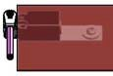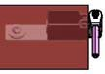abrasive belt misalignment switches (perpendicularly to the aggregate in a 10 mm distance from the abrasive belt)
* abrasive belt tension switch (the switch roll is between the stops when the belt is tightened)
* motor starter ( position „I“)

accessories

* aggregate frequency converter (without fault report)

#### Grinding Belt Stretching

* Use a hand valve on the aggregate to control stretching roller lifting and dropping

#### Putting the Machine into Standby Mode

#### BEFORE STARTING THE MACHINE, CHECK THAT NO MATERIAL, OR ITS REMAINS, WAS LEFT ON THE FEEDING BELT.

* Switch the main switch to position ’I’
* Machine safety circuit must be in order
* two-speed motor switch unit must be set to "0"
* Press the white button of control voltage
* after pressing it, the button lights up white

#### Emergency Halt

 IN DANGEROUS SITUATIONS WITH RISK EITHER TO OPERATING PERSONNEL’S HEALTH OR OF MACHINE DAMAGE!

* Press emergency halt buttons (EMERGENCY HALT buttons in front on the control panel and in the back in the middle); the machine must stop within 10 seconds.
* After they are pressed, emergency halt buttons remain locked

#### Machine Start after an Emergency Halt

* To restart, set the emergency buttons back to operating position (pulled out)
* If a material was left in the machine, perform emergency workpiece removal from the grinding aggregate and remove it.
* Switch all switches to ‘0’ position.

#### BEFORE RESTARTING THE MACHINE, CHECK THAT THE GRINDING BELT WAS NOT TORN OR OTHERWISE DAMAGED DURING THE EMERGENCY HALT.

#### Machine Stopping in Electric Outage

In case of an electric outage, the machine turns itself off, activating an electro-pneumatic brake that stops it within 10 seconds. After the machine stops, turn off the main switch. If you do not turn the main switch off, when the outage is over, the machine does not start on its own – it has a power outage stop.

#### Machine Starting after Electric Outage

* If the material remained in the machine, perform emergency retract the table (see Section Emergency retract the table) and remove the workpiece.
* Switch all switches to ‘0’ position.

#### BEFORE STARTING THE MACHINE, CHECK THAT THE GRINDING BELT WAS NOT TORN OR OTHERWISE DAMAGED DURING THE POWER OUTAGE.

#### Setting of workpiece height (thickness)

standard

* Measure workpiece thickness
* Deduce the required reduction from this value

#### THE REDUCTION VALUE MUST BE LOWER THAN THE MAX. REDUCTION ALLOWED WITH REGARD TO THE DRIVING MOTOR POWER AND IN CONNECTION TO OTHER CUTTING

#### CONDITIONS SELECTED.

* use the stroke controller to set the height displayed on the measuring
* while holding down the control stroke downwards table must move downwards (the value displayed on admeasuring increases).
* When pressing the lift control up the adjustable frame must move upwards (the value displayed on metering reduces).
* metering the workpiece height (positioner)
* insert the workpiece between the positioner support fixed on the side workbench beam, and the upper part of the positioner with microswitch
* depending on the workpiece thickness, the bench needs to be adjusted in a position not to damage the microswitch whilst pushing the workpiece in
* always shift the bench by approx. 5 mm lower than is the microswitch
* push the workpiece on the bottom support of the positioner
* drive the stroke controller upwards until it is stopped by the microswitch of the positioner.
* take the workpiece out of the positioner
* using the stroke controller, shift the bench as required by the information on the display
* the value of reduction can be also preset on the controller using a scale where one part equals to 0.1 mm

Accessories – two-gear stroke

* Joystick serves for approximate workpiece height (thickness) adjustment
* button with arrow serves for fine workpiece height (thickness) adjustment

Accessories- automatic metering the workpiece height (automatic positioner)

* if the workpiece cannot be pushed in between the positioner support fixed on the side workbench beam and the upper part of the positioner with microswitch
* press the yellow area around the positioner support with the workpiece that serve as a switch
* if the gap between the positioner support and the upper positioner part is sufficient (always about 5 mm bigger than the workpiece)
* insert the workpiece between the positioner support fixed on the side workbench beam, and the upper part of the positioner with microswitch
* the machine positions automatically until stopped by the microswitch of the positioner
* take the workpiece out of the positioner
* using the stroke controller, shift the bench as required by the information on the display
* the value of reduction can be also preset on the controller using a scale where one part equals to 0.1 mm

#### Display height (thickness) of workpiece

* the final height (thickness) of the workpiece displays on the metering system
* the machine can be equipped with adjustable rollers and foot

#### CHANGE THE SETTING CYLINDER A HEIGHT-ADJUSTABLE WHEN CHANGE OR PARTICLE SIZE OF ABRASIVE BELT. ADJUSTMENTS MUST BE CHECKED TRANSDUCER BELOW, THE

#### FUNCTION AND SETTING OF THE MEASURING DEVICE ARE DESCRIBED IN DETAIL.

#### Emergency Workpiece Removal from the Grinding Aggregate

#### IF THE MACHINE STOPS DURING PERFORMANCE OF AN OPERATION AND CANNOT BE PUT IN STANDBY MODE. TO TAKE OUT THE WORKPIECE, IT HAS TO BE DRIVEN AWAY FROM THE

#### GRINDING AGGREGATE!

* Main switch in ‘I' position
* Press the emergency halt button on the control panel
* STOP BAR must be either compressed or deflected
* Hold down the stroke controller
* the bench moves downwards and material is released

#### Aggregate Motor Starting/Stopping

standard - automatic aggregate motor start 0-Y(star)- ∆ (triangle)

* Press green ‘I’ button on the aggregate
* Motor starts by Y
* After about 30 seconds, the motor automatically switches from Y to ∆
* To turn it off, press the ‘0’ button on the aggregate

Accessories – two-gear aggregate motor

* 1. gear
* switch the two-gear aggregate motor switch to position “1“
* the motor starts rotating at required rpm
* 2. gear
* switch the two-gear aggregate motor switch to position “2“
* the motor starts rotating at lower rpm
* after approx 10 seconds the motor automatically switches to required rpm
* to turn it off, switch the two-gear aggregate motor to position “0“ Accessories – frequency converter of aggregate motor
* Use the potentiometer to set the required grinding belt speed within its given range
* Press green ‘I’ button on the aggregate
* After about 30 seconds, motor reaches revolutions required
* To turn it off, press ‘0’ button on the aggregate

#### Material Feed Start

Can only be started if: - standard - aggregate motor is switched in ∆ (triangle )

* + two-gear aggregate motor – the aggregate motor turns at required rpm
  + Frequency converter of aggregate motor - aggregate motor is on

- the module of cleaning members with rotary brush – the module motor is on

* Press green ‘I’ button of the feed
* select required speed using the cam switch 1-0-2

Accessories

Use the potentiometer to set required feed speed within given range

* To turn it off, press the red ‘0’ feed button

#### Pneumatically timed abrasive belt blow

* use the switch to select the required cleaning mode
* 0 (off)
* MAN (manually) – the abrasive belt is cleaned continuously
* AUT (automatically) – the abrasive belt is cleaned as long as the material is being machined by the machine

#### Switching on/off the vacuum bench pump motor

Standard

* Press the green “I” button of the vacuum bench pump motor

Accessories - automatic vacuum bench pump motor start-up 0 – Y (“star“) – ∆ (“triangle“)

* Press the green “I” button of the vacuum bench pump motor
* motor switches to Y
* after approx 60 sec. the motor automatically switches from Y to ∆
* for switching off press the red “0“ button of the vacuum bench pump

#### Machine mode selection

* for individual operations, see 7
* use the switch to select the required machine mode
* OSCILLATION ON (sanding belt oscillation is in operation for standard grinding abrasive)
* OSCILLATION OFF (sanding belt oscillation is turned off for elastic grinding abrasive)
* SERVICE - can open the side door to adjust the elastic abrasive
  + Sanding belt oscillation is off
  + Can not start displacement
  + Additional features machinery unlimited

## 4.3 MACHINE ADJUSTMENT AND SETTING FEATURES

Machines of MAXX 4production line are equipped with mechanical and pneumatic features for setting and adjusting of machine’s working parameters.

#### Mechanical setting features:

* adjusting nuts on operating roller and foot stroke mechanism – these elements serve for adjustment of the position (height) of the operating part of machines
* Adjusting stop screws on two-position roller and foot adjusters – these members serve for adjusting the position

(height) of the working parts of machines with above-standard equipment

* Regulation tensioning bolt stretches and centres machine feed belts
* Regulation bolts for setting the height and pressure force of the pressure rollers
* Adjuster bolts with nuts for setting the parallel (consistent) position of grinding foot and feeding table plane
* Adjuster bolt with nut onto the oscillation pneumatic roller piston rod – by setting optimum length of this piston

rod (pull) adjust the evenness (consistent speed of movement on the left and right side) of the abrasive belt

lateral movement on the grinding unit rollers

#### Setting features of the pneumatic system:

* + Reduction valve of the input pressure on the input unit of air adjustment – set operating air pressure (5.5. bar)

and tension force of the grinding belts

* + Oscillation circuit pressure control valve – sets optimum pressure (3-4 bar) in the abrasive belt oscillation

circuit

* + Throttle valves on the oscillation pneumatic rollers – set the uniformity of engaging and ejecting the piston rod

(pull) of the pneumatic roller, and thus also the uniformity of the tension roll turning

* + Throttle valves mounted on rollers of operating rollers stroke control and foot rollers – control the speed of

lifting and lowering the foot

## 4.4 MACHINE DESIGNATION – PRODUCTION PLATE

Business type machine designation and manufacturer’s logo are on the front part of the machine BULDOG. The designation is on a production plate placed on the back side of the frame; it contains the following data:

* + - Manufacturer’s name and address;
    - Business name and type of the machine;
    - Serial number
    - Total weight;
    - Year of production;
    - Drive electromotor revolutions;
    - Nominal current;
    - Nominal current;
    - Controlling circuit voltage;
    - IP protection;
    - Max. workpiece weight;
    - Electric voltage;

#### MACHINE OPERATOR MUST ENSURE ALL MACHINE DESIGNATION PLATES ARE VISIBLE AND UNDAMAGED DURING THE ENTIRE TIME OF MACHINE USE. IF THE PLATES ARE DAMAGED, THE

#### OPERATOR MUST REPLACE THEM IMMEDIATELY.

### 4.4.1 WARNING SIGNS

* The warning symbol of moving parts of the machine is located in the front and rear part of the machine, next to the inlet and outlet area for workpieces, and on the tilting part of the exhaust piping.
* Warning sign for the risk of electric voltage injury is placed on the electrical control panel door, connection box of electrical energy input, and the control panel.
* the warning symbol of injury hazard by the moving parts of the machine placed on the upper opening cover. This warning symbol prohibits opening the upper cover when the machine is in run.
* the warning symbol of injury hazard placed on the tilting part of the exhaust piping above the planning (routing) roller identifies the risk of injury by the tool blade.

#### WARNING: MACHINE OPERATOR MUST ENSURE ALL MACHINE DESIGNATION PLATES ARE VISIBLE AND UNDAMAGED DURING THE ENTIRE TIME OF MACHINE USE. IF THE PLATES ARE DAMAGED,

#### THE OPERATOR MUST REPLACE THEM IMMEDIATELY.

|  |  |  |
| --- | --- | --- |
| POSITION | GRAPHIC SIGN | MEANING OF THE SIGN |
| 1 |  | beware, caution |
| 2 |  | beware, electrical device |
| 3 |  | ground supply |
| 4 |  | main switch |
| 5 |  | operating pressure |
| 6 |  | stop bar |
| 7 |  | CE |

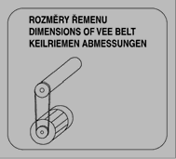

|  |  |  |
| --- | --- | --- |
| 8 |  | belt dimensions |
| 9 |  | grinding belt dimensions |
| 10 |  | rotation direction |
| 11 |  | control of R, C aggregate stretching belt |

# 5 TRANSPORT, HANDLING & STORAGE

## 5.1 MACHINE TRANSPORT

Transport by motoric or manual fork trucks the forks of which are slipped under the central elevated part of the machine. The operating part of the lifting device must overlap the machine frame bottom part by 50 mm in both directions.Transport by cranes, suspension of machine to be performed a sling provided with four suspension hooks. Four suspension lugs located in the upper part of the machine serve for suspension. During transport, only lift the machine to the minimum height required for the transport.

MACHINE TRANSPORT

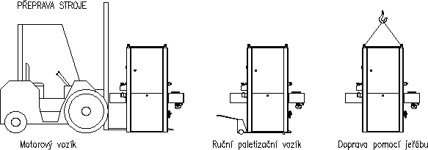

Motorized fork lift Manual pallet stackers Transport by crane

THE CAPACITY OF LIFTING DEVICES MUST CORRESPOND WITH MACHINE WEIGHT GIVEN ON  MACHINE’S PRODUCTION PLATE. TRANSPORT DEVICES MAY ONLY BE OPERATED BY

COMPETENT PERSONNEL.

DURING THE TRANSPORT, THE MACHINE MUST BE SECURED FROM MOVING  (BY TYING IT) OVER THE BOTTOM MACHINE FRAME UNDER THE WORKTABLE

AND THE AGGREGATE.

DURING ITS TRANSPORT, IT IS FORBIDDEN TO FASTEN THE MACHINE ACROSS THE WORKTABLE  AND GRINDING AGGREGATE – RISK OF MACHINE DAMAGE. MANUFACTURER’S WARRANTY

DOES NOT COVER SUCH DAMAGE.

## 5.2 MACHINE STORAGE

Machines can only be stored in dry aerated premises. Set the machine on an even fortified surface. For easier handling, machines have wooden blanks screwed to the bottom side of the frame. The machine is to be set on those blanks during storage.

#### MACHINE CONSTRUCTION AND ITS PACKAGING DO NOT ALLOW VERTICAL STRAINING; THIS IS WHY IT IS FORBIDDEN TO STACK THE MACHINES ON TOP OF EACH OTHER, OR OTHERWISE STRAIN THEM,

#### DURING BOTH TRANSPORT AND STORAGE.

# PLACEMENT, CONNECTING, AND PUTTING THE MACHINE IN TO OPERATION

## 6.1 MACHINE PLACEMENT

Deliver the machine to the place required, following instructions given in part 5.1 MACHINE TRANSPORT herein. The machine must be set on an even concrete surface into which mechanical machine anchors may possibly be anchored. Only machines that are set properly ensure the achieving of prescribed parameters of grinding accuracy and surface quality. When selecting a place for machine placement, it is necessary to add the maximum parameters of workpieces machined, increased by at least 1 meter, to both front and back of the machine. On the left hand side, 1 m clearance from the machine is required. On the right hand side, the min. clearance equals the grinding belt width plus 1 m. The clearing must allow easy and complete opening of side doors for the purposes of maintenance and cleaning; chiefly on the left hand side, for easy grinding belt exchange. The work area must be adequately lighted; the electrical network, pressured air distribution, and exhaust pipeline access points must be within reach.

During machine placement, follow these instructions:

a/ After the machine is set to a given place, disassemble the bottom side covers. Lift the machine approx. 80 mm above the floor. Remove 4 washers and release wooden blanks on the bottom of the frame.

b/ Screw the M12/M16 (based on machine type) levelling screws from the bottom cross beam of the frame so that their ends come out approx. 10 mm under the machine frame. Set the washers under the levelling screws. By screwing the levelling screws into the washers, lift the machine lightly so that it stands on the washers.

c/ Remove lifting device

d/ Put a bubble level on the worktable both longitudinally and transversely, and put the machine in horizontal level using levelling screws.

#### ANCHORAGE AND INSTALLATION OF MACHINERY

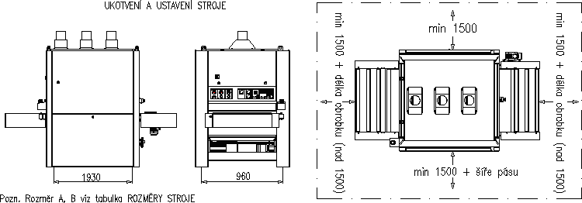

DIMENSIONS

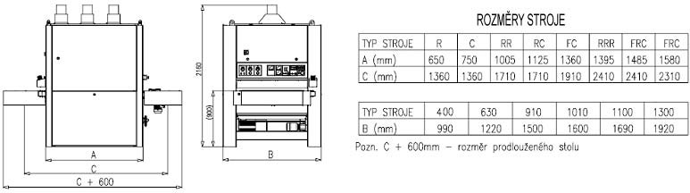

**NOTE:** THE LENGTH TABLE HAS AN ORIENTATION CHARACTER. DIMENSIONS A AND C ARE DEFINED BY THE MACHINE CONFIGURATION AND POSITIVE TYPES OF AGGREGATES, AND THEY CAN DIFFER.

#### NOTE: IN CASE OF ORDER, FITTING AND COMMISSIONING OF NEW MACHINES ON THE TERRITORY OF THE CZECH REPUBLIC ARE PROVIDED EITHER BY THE MANUFACTURER, OR BY A CONTRACT PARTNER.

## 6.2 CONNECTION TO ELECTRIC NETWORK

#### THE CONNECTING NETWORK MUST COMPLY WITH THE PARAMETERS SPECIFIED ON THE MACHINE PRODUCTION PLATE.

The machine is connected to electric network by a cable (must have a guard wire). The cable is connected into the control panel in the upper right machine part.

Rating and series protection of supply mains must meet machine power demands.

Maximum machine power is designated on the production plate; it differs based on components used. The machine is equipped with an M8 grounding screw for attaching of an independent ground wire.

 FOR SAFETY REASONS, IT IS ESSENTIAL THAT THE MACHINE IS PROPERLY GROUNDED. RISK OF STATIC ELECTRICITY!



IF THE MACHINE CONTAINS A FREQUENCY CONVERTER, IT IS POSSIBLE THAT A 30 mA

CURRENT PROTECTOR WILL DEAL WITH ELECTRIC SUPPLY OUTAGE. BASED ON CONNECTION

OF A DISTRIBUTION NETWORK, USE OF 100 mA CURRENT PROTECTOR NEED TO BE

CONSIDERED.

IF THE MACHINE IS EQUIPPED WITH A FREQUENCY CONVERTER, IT IS NECESSARY TO READ ITS PROPERTY THAT IT IS A PROGRESSIVE DISCONNECTION AFTER DISCONNECTION FROM THE CURRENT, EVEN IN CASE OF TOTAL STOP. THIS FEATURE REQUIRES ABOUT 1 MINUTE. SITUATION MAY ALSO COMPLY WHEN THE OPERATOR TURNS ON THE WHITE BUTTON TOO QUICKLY AFTER SHUTDOWN. THEN ERROR MESSAGES MAY APPEAR ON THE DISPLAY AND THE SCREEN DOES NOT RESPOND TEMPORARILY. As soon as the FREQUENCY INVERTER is STARTED, THESE ANY ERROR MESSAGES WILL DISAPPEAR AND THE SCREEN WILL START. THE MACHINE IS READY FOR OPERATION

#### INDIVIDUAL PHASE SEQUENCES OF THE ELECTRICAL NETWORK MUST BE MAINTAINED.

The inspection is performed by activating the controlling voltage after connecting the machine to the electrical mains:

* while holding down the control stroke downwards table must move downwards (the value displayed on admeasuring increases).
* When pressing the lift control up the adjustable frame must move upwards (the value displayed on metering reduces)

MAXIMUM CARE AND ATTENTION IS REQUIRED WHEN CONTROLLING PROPER PHASE

 SEQUENCE. IMPROPER CONNECTION MAY RESULT IN MACHINE BREAKDOWN AS WELL AS MECHANICAL DAMAGE TO CERTAIN MACHINE COMPONENTS.

WARRANTY DOES NOT COVER UNQUALIFIED CONNECTION AND CONSEQUENT DAMAGE TO THE MACHINE.

 CONNECTING, MAINTENANCE, AND REPAIRS OF ELECTRICAL EQUIPMENT MAY ONLY BE PERFORMED BY QUALIFIED, PROFESSIONAL MECHANICS IN ACCORDANCE WITH

APPROPRIATE NATIONAL REGULATIONS AND STANDARDS.

 ELECTRICAL SUPPLY FITTINGS MUST BE PERFORMED ACCORDING TO APPROPRIATE NATIONAL REGULATIONS AND THE REQUIREMENTS OF RESPECTIVE STANDARDS. THE POWER

CORD AND THE PLUG MUST BOTH MEET THESE STANDARDS.



THE POWER CORD AND ELECTRICAL FITTINGS MUST BE INSPECTED REGULARLY IN

ACCORDANCE WITH APPROPRIATE NATIONAL REGULATIONS. DAMAGED CABLES AND

PLUGS, OR OTHER ELECTRICAL FITTING COMPONENTS, IF APPLICABLE, MUST NOT BE

USED. DAMAGED

INSULATION OR DAMAGED COMPONENTS OF ELECTRICAL FITTINGS, IF APPLICABLE, PRESENT A LIFE THREAT. FREE ELECTRICAL PARTS (CABLES) MUST BE PROTECTED AGAINST MECHANICAL DAMAGE AND MUST NOT CREATE AN OBSTACLE IN THE WORKING AREA.

CONNECTING THE MACHINE TO THE ELECTRICAL SYSTEM, COMPRESSED AIR AND SUCTION

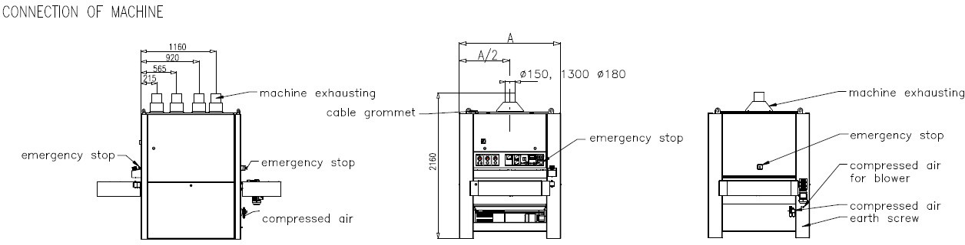

## PRESSURED AIR CONNECTION

 PRESSURED AIR DISTRIBUTION SYSTEM MUST CONTAIN PRESSURED AIR WITHOUT CONDENSED WATER AND OTHER PARTICLES AND DIRT.

 MINIMUM PRESSURED AIR SUPPLY MUST CONSTANTLY BE AT 0.6 MPA (6 BAR).

Connection must follow these instructions:

* Check pneumatic system features 4.
* Connect pressure air supply hose with a quick coupling on the inlet locking ball valve attached to the inlet unit f air adjustment.
* Let the pressured air into the pneumatic system of the machine by turning the hand valve lever.
* Check the setting of pneumatic system’s setting features.

## CONNECTING DEVICE EXHAUSTING

Suction pipe suction system with a diameter of 150 mm is connected to the inlet ports at the top of the machine and ensure clamps. Number of connecting duct work corresponds to the number of installed units, if the unit is installed in the machine type C. If the machine does not contain C-type unit machines are added one more outlet for exhaust from the machine.

Intake system draws air working units slotted hole in the level of work rolls. Extraction of the upper interior space can be optimally set a sliding shutter. Perfect function suction system provide only if connect the machine to vacuum system, which meets the criteria set out in section 4.1 TECHNICAL DATA.

#### WARNING: EXHAUST SYSTEM MUST BE PROTECTED AGAINST ELECTROSTATIC DISCHARGE. IF THIS CONDITION IS MET RISK OF EXPLOSION AND FIRE.MACHINE COMMISSIONING

## FIRST START MACHINE

* If we have made any previous preparation and control operation 6 we can proceed to the first start of the machine
* After previous operations, the machine is ready for operation instructions for use, work procedures

# INSTRUCTIONS FOR USE, WORK PROCEDURES

## GENERAL RULES FOR WORKING ON THE MACHINE

WHEN WORKING ON THE MACHINE, STRICTLY FOLLOW ALL RESOLUTIONS OF THIS GUIDE, WITH  EMPHASIS ON THOSE IN PART 2.2 RULES OF SAFE WORK. WIDE BELT GRINDER CINDY 3M(W) IS

DESIGNED FOR THE GRINDING OF SURFACES OF COMPONENTS LAID ON THE MACHINE’S WORKTABLE.

 COMPONENT SIZE AND WEIGHT MUST BE SUCH SO AS TO SECURE PERFECT MOUNTING, GRIPING, AND HANDLING DURING INDIVIDUAL WORK ACTIONS.

## CONTROL – TURNING THE MACHINE ON AND OFF

MACHINE START – Turn the main machine switch into position ‘I’. Press the white button of the control voltage to put the machine into standby.

MACHINE STOP – stop the grinding belt by pressing the red button, marked ‘0', on the motor starter. In emergency, the machine can be stopped by pressing the STOP button. Turn the machine off completely by turning the main switch into the '0' position.

For more detailed machine control see Annex 10 to this Guide – Control System Guide.

## ADJUSTMENT OF GRINDING UNITS

Arrival of grinding unit to required height in order to achieve the required thickness of the workpiece can be carried out by adjusting the height of the bench as advised on the display. For setting based on the machine’s gauge display, first measure the workpiece thickness (usually in several places) and define the reduction value based on the required thickness of resulting workpiece. If the reduction value meets the terms of maximum reduction allowed, as well as other cutting conditions selected, set the adjustable frame to a position where the display data is identical with the required thickness of resulting workpiece. After grinding the first piece, the grinding unit may be adjusted (workpiece thickness) based on either cutting conditions selected or level of grinding belt blunting.

 REDUCTION (IN MILLIMETRE DECIMALS) IS ALWAYS CHOSEN SO THAT IT MEETS THE QUALITY OF PRODUCT GROUND; NOT TOO LARGE TO AVOID UNNECESSARY MACHINE LOAD AND HEATING OF

BOTH WORKPIECES (WHICH MAY THEN DEFORM) AND THE GRINDING BELT. IT IS ALWAYS NECESSARY TO TRY THE SMALLEST POSSIBLE REDUCTION THAT MEETS THE QUALITY OF SURFACE GROUND. BOTH QUALITY AND REDUCTION ARE INFLUENCED BY USING SUITABLE BELT GRAIN SIZE AND CUTTING CONDITIONS OF THE GRINDING (SPEED OF GRINDING AND FEEDING BELT).

 IT IS FORBIDDEN TO ENTER MATERIAL THAT, DUE TO PREVIOUS GRINDING (HEAT), CHANGED ITS ORIGINAL SHAPE (GOT BENT OR CROOKED) INTO THE MACHINE. YOU MUST WAIT FOR THE

MATERIAL TO COOL OFF AND RETURN TO ITS ORIGINAL SHAPE.

## RINDING WITH ELASTIC ABRASIVE

For this type of belt, tension arm must secured by means of plastic nuts from both sides of the aggregate, and the oscillation function turned off. Therefore the standard version of the machine is provided with an abrasive belt oscillation mode alteration switch. The alteration switch has the below functions:

* + 1. SERVICE - this mode allows starting up of the main motor with the door opened, in order to straighten the elastic belt.
    2. OFF - for grinding with elastic belt
    3. ON - for standard belt types

# GRINDING BELTS - REQUIREMENTS – STORAGE

Machines of MAXX 4production line may only use grinding belts whose parameters correspond with grinding belts data given in part 4.1 TECHNICAL INFORMATION. The grinding belt joint must be of high quality, as its quality directly influences the quality of surface ground, especially in fine grinding.

 DAMAGED AND DEFORMED BELTS MUST NOT BE USED.

ONLY USE GRINDING BELTS WITH ANTI-STATIC FINISH ON THE MACHINE.

## GRINDING BELT STORAGE

If possible, grinding belts should be stored in original delivery packaging, in areas of constant temperature and humidity. Disproportionate fluctuation of storage temperature and humidity may cause permanent deformation to the grinding belt, resulting in their deterioration. Never use damaged and deformed grinding belts. Both grinding quality and grinding belt life directly depend on belt storage. Always store belts in original packaging, in temperatures from 15 to 25°C, and humidity from 40 to 70%.

## GRINDING PAPER EXCHANGE

Grinding paper exchange is described in Chapter 9.1.

## GRINDING PAPER PURCHASE

It is possible to purchase grinding belts, rollers, graphite on fabric, and other grinding components and woodworking tools

from authorised dealers or directly from machine manufacturer – see address par. 17.

# MACHINE MAINTENANCE AND SETTING

#### CAUTION! BEFORE ANY MACHINE INTERVENTION, PUT THE MAIN SWITCH INTO ‘O’ POSITION – TURNED OFF!

## 9.1 GRINDING BELT EXCHANGE

When exchanging a grinding belt, move the adjustable frame by approx. 60 mm up and follow the instructions below: a/ Press the STOP button and open the right side door of the machine; set the lever of manual pneumatic valve placed in the centre of the work unit into the bottom position, releasing the grinding belt.

b/ using the manual release lever adjustable footrest grinding unit and a shift toward remove it. c/ Remove the released grinding belt by taking it slowly out towards yourself.

d/ Clean the cylinder and the sensor oscillations when they are dirty e / new sanding belt is slipped over the cylinder working unit, and gently drifts when the cylinders until the edge of the belt is about 10 mm from the shoulder (with ceramic roll) mechanical limit switch. Overthrust brace it will establish a working unit and tighten the locking screw.

f/ Reset the manual valve lever; stretch out the belt; and check that the belt is set between the arms of the end switches; close the side door.

g/ turn the machine on and check the oscillation. If the belt slides down and does not oscillate, adjust the centring as advised in 11.6

h/ press the white button of the control voltage circuit which means that the machine is ready for operation

Manual pneumatic valve

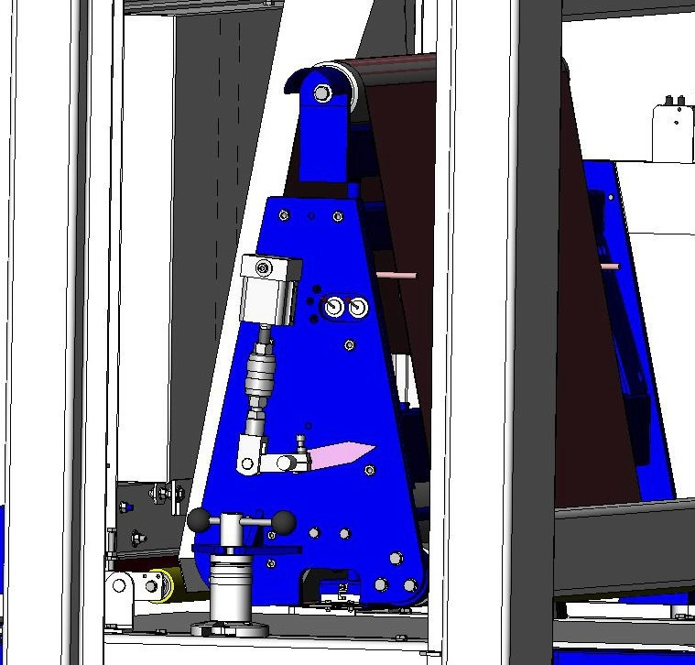

sanding belt

Roll of limit switch

Hand lever

adjustable backrest

#### CAUTION! ALWAYS INSERT THE GRINDING BELT IN THE DIRECTION OF ARROWS SHOWING THE DIRECTION OF GRINDING BELT MOVEMENT. DURING GRINDING, GRINDING BELT MOVES IN THE

#### DIRECTION OF THE ARROW ON THE SIDE OF THE GRINDING UNIT; ALWAYS IN THE DIRECTION CONSEQUENT TO THE MOVEMENT OF WORKPIECE GROUND, COUNTER-CLOCKWISE. WHEN EXCHANGING THE BELT, ALWAYS CLEAN (RINSE AND WIPE) ANY FILINGS FROM THE INSIDE OF THE MACHINE.

## 9.2 TENSION DRIVE CHAIN LIFTING TABLE

Checking the tension of the drive chain lifting mechanism workbench performed about once per month about 200 hours. Access to the drive chain is obtained by removing the lower side covers. Tensioning mechanism is on the right side of the machine. Tension is made by using the screw provided with a plastic head that is secured with locking nut.

chain

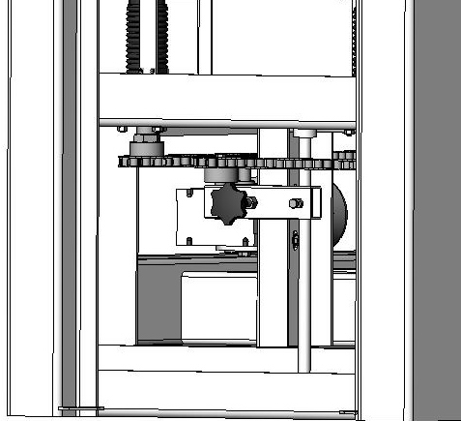

tensioning mechanism

locking screw

Tension screw

## 9.3 STRETCHING OF THE DRIVING BELTS OF GRINDING AGGREGATE

With new machines, check the tensioning after approx. 20 hours of operation. After belt setting, perform the check approx. every 50 hours of operation.

Perform the tensioning by moving the flange motor in the assembly panel grooves. First, lightly release four motor fastening bolts. Then release upper nuts on the bottom of the adjustable frame, gradually tightening the nuts on the bottom side of the frame bottom. Proper tensioning is such that pressure applied on the belts in the middle results in approx. 5 to 10 mm slack. After achieving the required tension, tighten upper nuts of the panel and tighten the four fastening bolts of the flange motor.

Pulley wheel engine braking

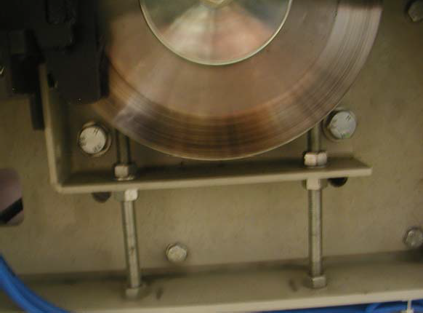

Motor mounting bolts

Tension nut

Plate tensioning mechanism

## 9.4 BRAKE SETTING

Pneumatic Disc Brake

Starting with serial number 1494, we mount a new system of grinding units braking in MAXX 4machines by means of pneumatic disc brakes. (Fig. 1.)

This braking method proved itself in the past; it is more efficient, easier to maintain, and has longer life.

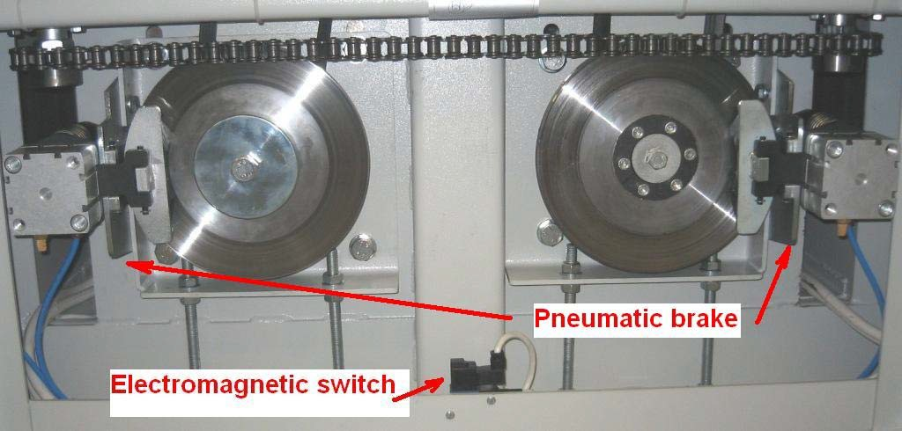

**1.1 solenoid switch**

**Pneumatic brake**s

(obr.1)

The system is based on a brake action induced by the pressure of a pair of springs onto the braking disc placed on the motor shaft. (fig. 2) Machine brakes are released by air pressure. To access the brakes, disassemble the left bottom machine cover.

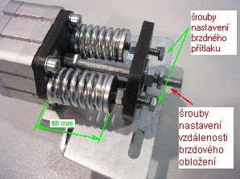(pic..2)

brake pressure adjustment screws screws set the distance the brake lining

The distance of braking segments is set with a central bolt on the back side of the brake. The force of braking springs is regulated separately for each spring, using a regulation bolt on the back side of the brake. (fig. 2)

Recommended spring compression is 55 mm (± 1mm).

#### CAUTION!

If the el. power supply is off (main switch in the OFF position), the engine is stalled. Roller checks and servicing required switching the electromagnetic valve manually (with a screwdriver) from position '0' to '1'. (fig. 3)

The electromagnetic valve is on the machine frame under the brake. (fig. 1) The motor is thus stalled.

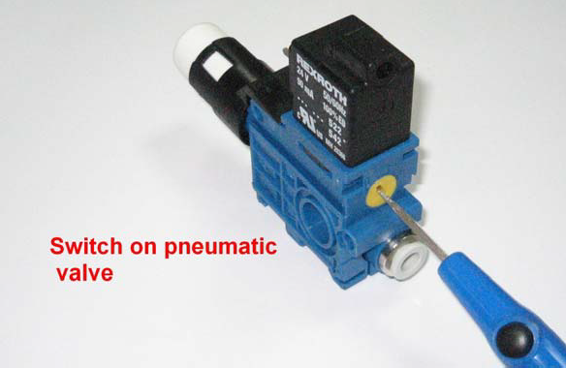

Recommendation:

It is recommended to disassemble both front and back machine covers during brake

## 9.5 FEEDING BELT CENTRING AND TENSION CHECKING

Correct feeding belt centring is such that the feeding belt moves on both driving and stretching rollers between longitudinal sections of the feeding table approx. 5 mm form the section edges. As the feeding belt is made of elastic materials, it is unevenly extended during grinding, which causes its movement sideways. To centre the belt, it must be extra-stretched on the side on which the belt deflected towards the edge section. To avoid disproportionate stretching of the feeding belt, it is always necessary to loosen it a little on the side opposite to the one where it is being tensioned. Correct tensioning of a feeding belt is such that the bottom belt part slack, under the worktable, is within a maximum of approx. 3 to 5 mm.

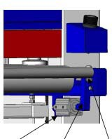

|  |  |  |  |  |
| --- | --- | --- | --- | --- |
| Tensioning Limit | Pneumatic | Pneumatic cylinder | Rod | Tensioning |
| screw switch | valve |  |  | screw |

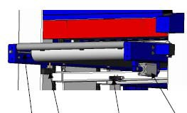Machines with automatic feeding belt centring only require basic belt initial tension. The belt is aligned automatically, using front stretching roller travel, which is, on the right machine side, implemented by a lever mechanism controlled by a pneumatic roller. Filling of this pneumatic roller is controlled by an electro-valve switched by a sensor on the left side of the feeding belt. Sensor arm has a plastic roll onto which the left edge of the feeding belt runs. Basic belt initial tensioning of this system is performed by a stretching bolt on the left side of the belt. A stretching bolt on the right side of the belt is used to set such a tension under which: if the piston rod of the pneumatic roller is projected, the belt slowly moves to the left; and if it is engaged, the belt moves to the right. Air pressure pneumatic cylinder tensioning force is the same as the pressure of the belt tensioning - about 5.5 bar.

Due to age and created by wear on the belt and inequality rubber band gradually hardens (material starts after SMEK belt). It is recommended that about 1 per year visit the service technician to check the machine (Refinished feed belt).

## 9.6 INSPECTION AND ADJUSTMENT FUNCTION OSCILLATION

As already mentioned the control oscillation belt sanding machines in series MAXX 4used electronic control oscillation by a sensor equipped with an infrared sensor. For proper function of the whole electro-oscillation system must be set correctly - air cylinder pneumatic circuit that provides an oscillating motion of the upper tensioning rollers and correct setting of the center position of the tensioning rollers which are alternately deflected.

If the belt oscillation to leave space between the two boundary limit switches (with ceramic roll) due to system failure or resentment, limit switches made an immediate emergency standstill. Know this situation so that the machine has stopped grinding belt is on the left or right side of the cylinder grinding unit. At this point it is necessary to check the pneumatic and electrical system oscillations

pneumatic cylinder

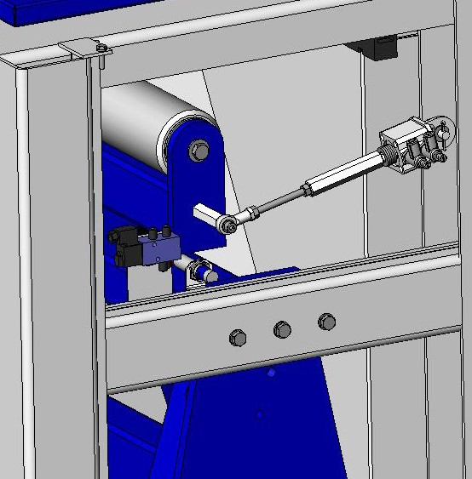

threaded rod

matrix

swivel eye

infrared sensor

pneumatic valve

### SETTING AND CHECKING PNEUMATIC CIRCUIT OSCILLATIONS

Perform the following procedure:

a/ Check the pressure oscillations in the circuit and where it is set to approximately 3.5 to 4 bar. the regulator, the pressure oscillation circuit and release the tension of the grinding belt.

b/ From the right side of the machine by opening the right side door set our grinding belt rollers for grinding units in the range of about 30 mm between the ceramic roll limit switches. At the moment there is a displacement of the upper tensioning rollers, leaving the left edge sanding belt oscillation beam sensor. From this position, the adjustment will move the tensioning roller grinding strip about 10 mm to each other (on the right side of the machine.) In this position, leave it and straighten.

**NOTE:** There is a time relay in the electric oscillation circuit that holds the voltage in the oscillation sensor when main motors are turned off and disconnects it within approx. 1 - 1.5 minute. to test oscillation, turn on and off the main motor which activates the time relay. Now we have about 1 to 1.5 min to test the oscillation.

c/ From the left side of the machine and releasing alternately covering our beam oscillation image sensor and monitor the movement of the upper tensioning cylinder control pneumatic cylinder rod. The movement should be smooth and both parties equally fast. If not, adjust the speed and uniformity of movement of the upper tensioning roller by throttling valves mounted directly on the pneumatic cylinder oscillation. Using a small screwdriver, slowly turn the center adjustment screw valves. In doing so we uncover and covering our beam sensor and monitor the movement of the tensioning rod cylinder. Each valve controls one direction of movement. Valves set so that the displacement at both sides equally rapid and lasted approximately 0.5 to 1 sec.

### SET THE CENTER POSITION

tensioning rollers do so, first find out which side is abrasive belt machine after an emergency stop. If the strip on the right side of the machine, the tension roller on the left side of the machine is too biased rearward. When sanding belt on the left side, the tension roller on the left side of the machine is deflected too far forward.Rod length is performed after releasing the nuts on the rod and it screwing or unscrewing the threaded part of the rod swivel eye or hexagonal parts dragged. This is performed by increments of about 1-2 threads. After setting the position again arrange nuts. Proper setting of the conditions of oscillation is such that when the sanding belt which moves on rollers up to 10 mm on both sides at the same speed with a frequency of about 40 to 60 swings per minute.

### OSCILLATION ADJUSTMENT

If oscillation is adjusted wrongly, the abrasive belt gets out of the reserved working area, and drives onto the marginal terminal switch. The machine turns off and brakes. Open the right door, switch the abrasive belt tension lever to the lower position and release the abrasive belt. Adjust oscillation by means of pull, as advised in par. 9.6.2 on the other end of the grinder. If the abrasive belt slides down away from the oscillation sensor, shorten (screw in) the oscillation pull and on the contrary. Once the oscillation is adjusted, Seat and stretch the abrasive belt as advised in par. 9.6.1.b, and close all doors.

 IF THE SIDE DOOR IS OPEN, OR THE ABRASIVE BELT TERMINAL SWITCHES ON, THE MACHINE CANNOT BE TURNED ON

Turn the machine on and test the oscillation. If the abrasive belt still slides down, repeat the adjustment until the oscillation gets centred.

## 9.7 SETTING THE LIFT AND PRESSURE FORCE OF PRESSURE ROLLERS

#### Rollers with swinging arms

Roller lift is set by levelling screws on the machine frame, accessible after opening the right side door. Screws are secured by a nut that needs to be loosed before changing the setting. The height is adjusted by screwing in – increasing roller lift height when feeding a workpiece; and screwing out – which lowers the roller lift height. Basic roller position is set when a workpiece, when fed under the roller, lifts it by approx. 2 to 2.5 mm. The table is set to a height at which the workpiece reduction is approx. 0.5 mm.

Setting the contact force is carried by steel springs that are hung on the adjusting screws anchored in the machine frame and the bracket on the shoulders of the rollers. Springs on both sides of the machine. In the arms of the pressure rollers are drilled three holes in which you can perform tension spring suspension, thereby altering the downforce. A small change in pressure forces the pressure rollers are changed using set screws, larger changes in strength is achieved by repositioning the suspension springs.

In some cases only the pressure force of the pressure rollers may be adjusted. For example, when grinding large and heavy workpieces using grinding belts of grain size 40; 60; 80, when both the roller lift and pressure force need to be increased; or when grinding narrow and light parts suing fine belts, when the roller lift and pressure force need to be decreased. The manufacturer sets new machines to optimum values suitable for most grinding procedures.

 RATCHET WITH LATCH IS MOUNTED ON THE FIRST THRUST ROLLER, WHICH PREVENTS WORKPIECE REJECTION FROM THE MACHINE.

#### Sliding pressure rollers

Height adjustment by sliding the rollers by means of nuts on the lower guide pin which fits into the rest position pivot bearings. The lower nut acts as a lock nut.

Setting the contact force to the sliding rollers performs a compression spring which bears on the pivot bearing. Preload set by the upper nuts on the guide pin.

See the annex "Adjustment of machines" for accurate values of machine setting.

Adjusting screw for adjusting the thrust of the roller

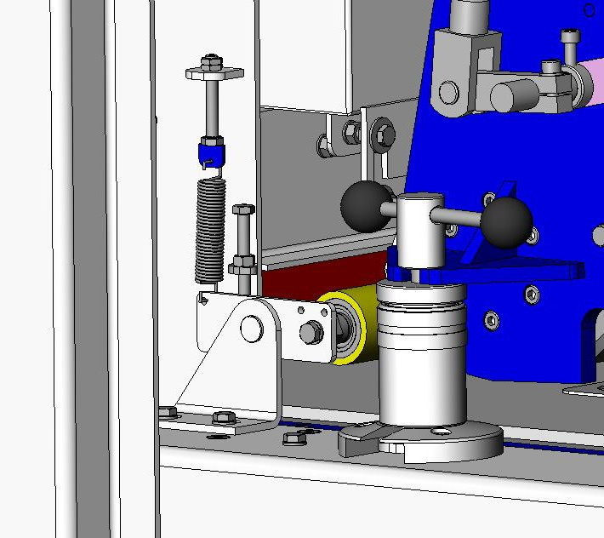

Adjusting screw for adjusting the stroke of the roller

Snub roll

Roller holder arm

## 9.8 REPLACEMENT ROTARY TOOLS - BRUSH WORK UNIT TYPE B

* Brushing MODULE

If the rotary tool wear work unit B or replace scrubbing module is as follows: a / Turn off the main switch and open the right side door

b / Dismantle side plate working units of type B or of brushing module

c / At brushing module further dismantle the swing arm and pull it with the bearing shaft with d / Loosen the locking ring nut screw and unscrew the nut and remove the shaft

e / Gradually pull rotary tools with shafts and after cleaning and inspection shafts Slip gradually new tools - brushes. f / if the tool carrier on the left side has a tang pin tool should be pushed onto the pin

g / Check the insertion tool on the tool shaft and secure by tightening the ring nut. Position of the matrix provide the retaining screw.

h / The shaft at brushing module slipped arm with bearing and screw it.

i/ Backward side mount plate, close the side door and the machine is ready for the next operation.

## 9.9 SETTING AND ADJUSTMENT OF THE MEASURING SYSTEM

#### Digital metering Elgo 54.500.230 – Pony, Cindy, MAXX 43, 5, 5M

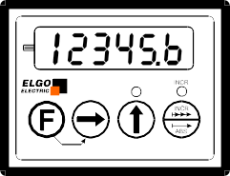

It is metering that displays the workpiece height (thickness) value on the exit from the machine. Metering scale

The  button is used to switch between the absolute (actual value) and incremental value.

When switched to incremental metering mode, the indication displays resets automatically, and red LED lights up. Once can then meter either in “+” or “-“ direction from that “zero”.

Next pressing the button  takes you back to the absolute value.

If in the absolute mode the value shown on metering and the value detected on the workpiece do not correspond

After finishing in the machine meter the thickness of workpiece on multiple spots (the differences between the measured value should range within the tolerance of 0.1 mm).

Adjust the display as per the below instructions.

+3sec. …Access to the value saved in memory 1.



…………………..Shifting the position of cursor (flashing position).

…………………..Changing current position numerical value + 1.

………………..Saving the setting, calling up the value from the memory 1 and return to the metering mode.

Pressing the +  buttons the value on the display rewrites with a value from memory 1.

When the buttons are pressed in incremental mode, metering switches automatically to absolute mode.

Use of memory 2

By pressing the  button the value in memory 2 is added to the value on the metering display, and the red LED lights up.

Example: In case of mechanical adjustment of the last aggregate in the row to a different position.

By pressing the last aggregate in the row to a different position (depending on the machine configuration), the value in memory 2 is added to the value on the metering display, and the red LED lights up.

Example: When the bounce/bound pneumatic foot is turned on, the foot lowers. At that moment, the value on the metering rewrites by the value by which the foot is lower towards the roller (0.1 mm is the standard set by the manufacturer).

Changing the value in memory 2

+ 3sec. …Access to the value saved in memory 2.



…………………... Shifting the position of cursor (flashing position).

………………….. Changing numerical value of current position + 1.

………………..Saving the setting and return to the metering mode.

# 10 MACHINE MAINTENANCE

## 10.1 MACHINE CLEANING AND LUBRICATION

#### CLEANING

Wide-belt grinder line MAXX 4 is a machine that does not require special maintenance. During machine maintenance, follow these instructions:

Clean the machine every day. This prevents occurrence of permanent sediments, ensuring reliable and safe machine operation. Minimum cleaning interval is after each 8 hours of operation. Cleaning machines perform suction sawdust from inside the machine by opening the side door. Clean the feeding belt in the same way. It is important to regularly clean the sensor oscillation. In case of heavy contamination of the sensor is threatened by its proper function. The lower part of the machine should be cleaned after removing the bottom removable covers on the sides of the machine located under the side door. Cleaning the bottom is performed according to the operating hours of machinery and power extraction device at least once a week.

For machines equipped with pneumatic flap segment divided perform daily cleaning segments. Segments foot slide out dust and air blow between segments feet.

In machines equipped with a working unit with routing roller, the thrust and block flaps at the entry to the machine must be cleaned regularly.

#### WARNING: DURING CLEANING MAKE SURE THAT FILINGS DO NOT GET UNDER THE FEEDING BELT. FILINGS AND OTHER DIRT UNDER THE FEEDING BELT CAUSE LOW GRINDING QUALITY – UNEVEN SURFACE GROUND.

#### LUBRICATION

Al machine bearings are lubricated by lubricating greases with long life and do not require lubricating during operation. The bearings have either covered on both sides or sealed with radial shaft sealing rings. Endless screws of the bench lifting mechanism must be lubricated in a similar manner.

## 10.2 MAINTENANCE OF FEATURES OF ELECTRICAL FITTINGS

 CONNECTING, MAINTENANCE, AND REPAIRS OF ELECTRICAL EQUIPMENT MAY ONLY BE

PERFORMED BY QUALIFIED, PROFESSIONAL MECHANICS IN ACCORDANCE WITH

APPROPRIATE NATIONAL REGULATIONS AND STANDARDS.

 DO NOT BLOW OUT THE ELECTRICAL CONTROL PANEL WITH PRESSURED AIR.

## 10.3 MAINTENANCE OF FEATURES OF PNEUMATIC SYSTEM

Input Air Filtration

* The first container behind the ball valve is for purging of water condensate and collecting of dirt
* Maximum condensate level is marked on the container
* Its disassembly and cleaning is performed after disconnecting of pressured air

Lubrication of Machine’s Pneumatic System

* Second container behind the ball valve contains pneumatic oil
* Min. oil level is marked on the container
* Its disassembly and oil refilling is performed after disconnecting pressured air
* turn or unscrew the bowl (depending on the type of the input unit)
* the contents of the bowls should be enough for 1 – 3 months of the machine operation (depends on the frequency of grinding)
* Above the oil container, there is a regulation screw for adjusting the amount of oil added
* tighten the bolt and then loosen by approx. 1 revolution, depending on the type of machine

WHEN REFILLING OIL IN THE INPUT ADJUSTMENT UNIT O F PRESSURED AIR, USE ONLY  PNEUMATIC OIL DESIGNED FOR THE PURPOSE (MANUFACTURER SUPPLIES PNEUMA 46 OIL BY

TOTAL). USING OTHER OIL TYPES MAY DAMAGE SOME MACHINE PARTS.

## 10.4 MAINTENANCE PLAN FOR WILD BELT SANDER

|  |  |  |  |
| --- | --- | --- | --- |
| Inspection period | Inspected machine part | Method | tolerances |
| Prior to each machine start-up | Air pressure | visually | 4.5 - 6.0 bar |
| Water presence in FLR unit vessel | visually | Unacceptable |
| Presence of foreign objects in the machine working area | visually | Unacceptable |
| Contamination of the oscillation  sensor | visually | Unacceptable, wipe |
| Sanding belts’ position | visually | Between the end switches |
| Sanding belts’ tension | visually | stretched (4.5-6.0 bar) |
| Air pressure control in the machine oscillator circuit | visually | 3 bar |
| Inspection and adjustment of the oscillation function of the sanding  belts | measuring | 40-60 oscillations per minute |
| Sanding belts’ damage | visually | Unacceptable |

|  |  |  |  |
| --- | --- | --- | --- |
|  | Fastening the aggregate support | Fastening inspection | No tolerance |
| Inspection of sanding shoulder | visually | As per the sanding technology |
| Feeding belt tension inspection | measuring | deflection 5 mm |
| Machine control elements must be  undamaged | visually | No damage |
| Closing of all covers and doors of the stands | visually | All closed |
| after shift  completion - 8 hours | Cleaning of the machine operating  area | Sawdust  suction | unacceptable contamination |
| Cleaning of the machine feeding belt | air blowing | unacceptable contamination |
| Cleanness and wear of sanding belts | visually | As per the sanding technology |
| Inspection of the feeding belt motor gearbox (oil leakage) | visually | Unacceptable |
| Oil inspection is in FRL unit | visually | Adding (TOTAL PNEUMA 46) |
| Cleaning the parts of sanding shoulder | air blowing | unacceptable contamination |
| After 80 hours of operation | Switchgear cleanness inspection | visually | Unacceptable contamination, suction cleaning, not ait blowing |
| Inspection of the ventilation grit filters  of the switchbox (fans) | visually | replacement |
| Switchgear leakage inspection | visually | replacement |
| Inspection of fastening electrical contacts in the switchgear | Fastening inspection | fastening |
| Measuring accuracy inspection | measuring | 0,1 mm (standard) |
| Inspection of mutual position of the operating rollers | measuring | As per the sanding technology |
| Adjustment inspection and function of the thrust rollers (bars) | measuring | As per the machine setting scheme |
| Inspection of wear and damage of the operating rollers | Visually, measuring | Potential replacement |
| Inspection of sanding shoulder  surface | visually | No damage |
| inspection of all safety components | test | unacceptable function failure |
| Checking the blowing function | visually | Function (40-60 oscillations per min.) |
| Inspection of the emergency brake  adjustment | measuring | spring compression is 55mm (±  1mm). |
| Lift chain tension inspection | measuring | No bending |
| Inspection of wedge belts tension | test | Bending force approx 5 mm |
| After 320 hours of operation | Inspection of motor area for cleanness | visually | suction |
| Inspection of the cutter plates state | Visually, measuring | No damage |
| Cutting plates fastening | Torque wrench | 6 Nm |
| inspection of bearings state and wear | Measuring, vibration, and | As per the bearing manufacturer |

|  |  |  |  |
| --- | --- | --- | --- |
|  |  | temperature |  |
| Inspection of the parallel operating rollers | measuring | 0,1mm |
| Inspection of the electromagnetic valves’ filter surface for cleanness | visually | suction |
| 1x year servicing inspection by the manufacturer (possible warranty  extension) | inspection of the feeding belt state  and wear | visually | The worked piece must not stop |
| inspection of machine general state and wear | Visually, measuring | Sanding accuracy with tolerance 0,1mm |
|  | | | |
| BEARING LUBRICATION  Al machine bearings are lubricated by lubricating greases with long life and do not require lubricating during operation. The bearings have either covered on both sides or sealed with radial shaft sealing rings. | | | |

# 11. TROUBLESHOOTING INSTRUCTIONS

#### MOST FREQUENT FAILURES AND THEIR REMOVAL

#### ANY WIRING REPAIRS SHALL ONLY BE PERFORMED BY AN ENGINEER ELECTRICIAN WITH PROPER QUALIFICATION AND AUTHORISATION AS REQUIRED BY RELEVANT NATIONAL

#### REGULATIONS; LET THESE REPAIRS BE CARRIED OUT BY AN AUTHORISED COMPANY.

|  |  |  |
| --- | --- | --- |
| Function defect on the machine | Cause | Removal |
| After pressing the white START button, controlling voltage remains inactive – the white button control light does not come up | interrupted supply of el. energy into the machine   * disconnected safety circuit * transformer does not produce controlling voltage 24V/60Hz | Check all safety switches in the circuit  in compliance with section 4.2. MACHINE SAFETY SYSTEM  Check fuses F1.F2,F3 in the supply transformer  circuit |
| Display OZD off | interrupted power supply 230V/50Hz | Check - replace fuse F4 |
| Driving motors of the working unit do not work | Disconnected motor starters Brake out of order | Check or start motor starters QF1 .. QF2... of relevant driving motors  Check fuse F5 of the electromagnetic brake circuit |
| Unable to start the feed belt does not lift table | disconnected motor starter | Check or start motor starter QF21 |
| Crush Grinding belt grinding unit rolls to the side and there is a stop | - Defective-deformed sanding belt.  -dysfunctional system oscillations sanding belt | Grinding belt-replace with a new  -Perform-adjustment system oscillations at the work unit according to the article 9.7 INSPECTION AND  ADJUSTMENT OF OSCILLATION |

|  |  |  |  |  |  |  |
| --- | --- | --- | --- | --- | --- | --- |
| The feeding belt is not centered in the Crush | Poorly set centering - feed belt tension | | | | | Adjust according to the article  9.6 CENTERING Poda-ing BELT TENSION CONTROL |
| Foot grinds inaccurately | Graphite damaged | layer | on | the | foot | Exchange the graphite layer |
| Material slides on the feeding belt | - hardened feeding belt | | | | | Re-grinding of the feeding belt – call the service shop |

# 12 MACHINE DISASSEMBLY AND LIQUIDATION

 IF THE MACHINE IS COMPLETELY PUT OUT OF SERVICE, DISCONNECT IT FROM THE EL. MAINS; RELEASE MACHINE ANCHORING, IF ANCHORED; AND SUBMIT FOR LIQUIDATION TO A FIRM SPECIALISED IN WASTE MATERIAL COLLECTION AND LIQUIDATION. WHEN LIQUIDATING THE MACHINE, FOLLOW RESPECTIVE NATIONAL REGULATIONS.

 ALL DISASSEMBLY WORKS RELATED TO MACHINE LIQUIDATION MUST BE PERFORMED BY QUALIFIED PERSONNEL FROM AUTHORISED COMPANIES.

# 13 MACHINE LIFE

Despite the fact that the wide-belt grinding machine MAXX 4 is made in the highest possible quality, machine life depends on proper attendance, maintenance, number of operating hours, and intensity of machine strain.

In order to achieve long life span, it is recommended to perform an overall check and adjustment of mechanical machine parts every 5 years. Such inspections should be implemented

# 14 ACCESSORIES DELIVERED WITH THE MACHINE

The wide-belt grinding machine MAXX 4is delivered completely assembled, based on customer’s order specifications in compliance with machine description given in paragraph 4.2.1 MAIN DESIGN GROUPS – for both standard and special equipment including a grinding belt and a special catch for opening the doors and el. control panel cover.

Each machine is delivered with one copy of this Guide. On request, customers may be provided with more copies, or have this Guide sent on a CD or by e-mail.

# 15 SPARE PARTS AND THEIR ORDERING

## 15.1 IDENTIFICATION OF PARTS

For each machine is supplied spare parts catalogue. Breakdown catalogue is done by the main machine assemblies. Each part has a number, which provides unique identification of the part. Always quote this number when ordering spare parts along with stating the machine serial number, according to the rating plate

## 15.2 ORDERING PARTS

The manufacturer delivers spare parts within the Czech Republic. Deliveries are implemented based on an order sent to manufacturer's address given in this Guide. Parts may be collected directly from the production plant; they may be sent as required, or agreed upon.

In other countries to which the machines are supplied, spare parts ordering is ensured via authorised national dealers.

# 16 SERVICE AND REPAIR SERVICES

## 16.1 CZECH REPUBLIC

Within the Czech Republic, the first commissioning, warranty, and after-warranty service are provided by the manufacturer. His contact place and address are given at the end of this Guide.

## 16.2 OTHER COUNTRIES

An authorised dealer is in charge of all services for machines exported to other countries; unless agreed upon differently with the customer on purchase.

# 17 MANUFACTURER'S CONTACT ADDRESS

#### HOUFEK a.s.

#### May 5, 797

#### CZ – 582 82 Golčův Jeníkov – Czech Republic

|  |  |
| --- | --- |
| **Tel.:** swichboard | +420 569 430 700 |
| export department | +420 569 430 710-712 |
| fax | +420 569 430 705 |
| service | +420 775 639 983  +420 569 430 749 |

#### E-mail: [houfek@houfek.com](mailto:houfek@houfek.com)

#### servis @houfek.com

#### internet: [http://www.houfek.com](http://www.houfek.com/)

#### 

**END OF GUIDE**

1. **ANNEXES**

ANNEX 1 Report on repairs implemented

ANNEX 2 Report on putting the machine into operation ANNEX 3 Single test form

ANNEX 4 Warranty certificate ANNEX 5 Certificate of conformity

ANNEX 6 Electric and pneumatic schemes

ANNEX 7 Technical data (if not included in the Guide) ANNEX 8 Controlling system guide (if part of the equipment) ANNEX 9 Machine setting